**LLIN Evaluation in Uganda Project (LLINEUP2)**

**Study Title:** Impact of long-lasting insecticidal nets

(LLINs) treated with pyrethroid plus pyriproxyfen vs

LLINs treated with pyrethroid plus piperonyl butoxide

on malaria incidence in Uganda: a cluster-randomised trial

**Sponsored by:** National Institute of Allergy and Infectious Diseases (NIAID)

**DMID Funding Mechanism:** NIH/NIAID U19AI089674

Principal Investigators: Prof Sarah Staedke, Prof Moses Kamya

Co-investigators: Prof Grant Dorsey, Prof Martin Donnelly,

Dr Joaniter Nankabirwa, Dr Catherine Maiteki-Sebuguzi, Dr Jimmy Opigo,

Dr Bryan Greenhouse, Dr Jessica Briggs, Dr Isabel Rodriquez-Barraquer,

Dr Catherine Pitt, Katherine Snyman

**Protocol Version 5.0, 10 Sept 2021**

Table of Contents

List of associated consent forms 5

List of appendices 5

Statement of compliance 6

Signature page 7

Abbreviations & acronyms 8

Study summary 9

Study personnel and institutions 10

Investigators 10

Collaborating institutions 12

Institutional review boards 13

1 Background 14

1.1 Introduction 14

1.2 Malaria control interventions in Uganda 14

1.3 LLINs in Uganda 15

1.4 IRS in Uganda 16

1.5 Health facility surveillance 17

1.6 Insecticide resistance 19

1.7 LLINs treated with piperonyl butoxide 19

1.8 LLINEUP trial 20

1.9 Dual active-ingredient LLINs with pyriproxyfen 21

2 Rationale 22

3 Study objectives 23

4 Study design & methods 24

4.1 Overview 24

4.2 Study sites 24

4.3 Randomisation 25

4.4 Sensitisation 25

4.5 Enumeration survey 25

5 Intervention 27

5.1 Overview 27

5.2 Household registration and LLIN distribution 27

5.3 Social behaviour change communication 28

6 Health facility surveillance 29

6.1 Data collection at MRCs 29

7 Cross-sectional surveys 30

7.1 Overview 30

7.2 Definitions 30

7.3 Household survey 30

7.4 Clinical survey 31

8 Entomology surveys 33

8.1 Overview 33

8.2 Recruitment and screening 33

8.3 Informed consent 33

8.4 Entomology survey 33

9 LLIN durability assessment 34

9.1 Overview 34

9.2 Net integrity 34

9.3 Chemical analysis of LLINs 34

10 Economic evaluation 35

10.1 Overview 35

10.2 Estimation of costs 35

10.2.1 Intervention costs 35

10.2.2 Malaria costs 36

10.3 Estimation of effects 36

10.5 Analysis 36

11 Laboratory procedures 38

11.1 Microscopy 38

11.2 Haemoglobin measurement 38

11.3 Finger prick blood samples 38

11.4 Rapid diagnostic tests 39

11.5 Molecular analysis of malaria vectors 39

11.6 COVID-19 testing 39

12 Data management 40

12.1 MRC surveillance 40

12.2 Cross-sectional community surveys and entomology surveys 40

12.3 Laboratory data 40

12.4 Quality assurance & quality control 40

12.5 Records & storage 41

13 Statistical issues 42

13.1 Outcome measures 42

13.2 Defining the MRC catchment areas 42

13.3 Measuring the incidence of malaria in the MRC catchment areas 42

13.4 Sample size and power calculations 42

13.5 Analytical plan 43

14 Ethical considerations 44

14.1 Institutional review boards 44

14.2 Informed consent process 44

14.3 Risks and discomforts 44

14.4 Compensation 45

14.5 Capacity development 45

14.6 Dissemination and publication of research findings 46

15 Proposed timeline 47

16 References 48

# List of associated consent forms

1. Cross-sectional community survey consent to participate in a research study (households) [V5.0]
2. Cross-sectional clinical survey consent to participate in a research study (parents/guardians) [V5.0]
3. Cross-sectional clinical survey consent for future use of biological specimens (parents/guardians) [V4.0]
4. Cross-sectional clinical survey assent form to participate in a research study (children > 8 years) [V5.0]
5. Entomology survey informed consent to participate in a research study (households) [V5.0]
6. Cross-sectional clinical survey consent to participate in a research study (adults) [V1.0]
7. Cross-sectional clinical survey consent for future use of biological specimens (adults) [V1.0]
8. Costing data collection consent to participate in a research study (health workers) [V1.0]

# List of appendices

Appendix A: Intervention allocation list

Appendix B: LLINEUP2 information sheet for sensitisation

Appendix C: HMIS Form 002

Appendix D: Malaria Reference Centre (MRC) data dictionary

Appendix E: Cross-sectional community survey screening form

Appendix F: Cross-sectional community household questionnaire data dictionary

Appendix G: Cross-sectional clinical survey screening form

Appendix H: Cross-sectional clinical survey questionnaire data dictionaries

Appendix I: Entomology survey screening form

Appendix J: Costing tools

Appendix K: Risk mitigation plan

# Statement of compliance

The study will be carried out in accordance with Good Clinical Practice (GCP) as required by the following:

* US Code of Federal Regulations applicable to Clinical Studies (45 CFR 46)
* ICH GCP E6
* Ugandan National Council for Science and Technology
* Completion of Human Subjects Protection Training
* NIH/NIAID Clinical Terms of Award

# Signature page

The signature below constitutes the approval of this protocol and the attachments, and provides the necessary assurances that this study will be conducted according to all stipulations of the protocol, including all statements regarding confidentiality, and according to local legal and regulatory requirements and applicable US federal regulations and ICH guidelines.

Site Investigator: Professor Moses Kamya, MBChB, MPH, PhD

Signed: ______________________________________________

Name: Moses Kamya

Title: Professor, Department of Medicine

# Abbreviations & acronyms

ACT artemisinin-based combination therapy

AL artemether-lumefantrine

AMF The Against Malaria Foundation

CAB community advisory board

DFID UK’s Department for International Development

DHS Demographic and health surveys

EDMIS electronic data management information system

EIR entomologic inoculation rate

GFATM Global Fund to Fight AIDS, Tuberculosis, and Malaria

GIS geographical information systems

GPS global positioning system

HMIS Health Management Information System

HSD Health Sub-District

IDRC Infectious Disease Research Collaboration

IRB institutional review board

IRS indoor residual spraying

ITN insecticide treated net

LC1 Local council chairman

LLIN long-lasting insecticidal net

LSHTM London School of Hygiene and Tropical Medicine

MIS Malaria indicator survey

MOH Ministry of Health

MRC Malaria reference centre

NCC National Coordination Committee (for LLIN distribution)

NMCP/D National malaria control programme/division

PBO piperonyl butoxide

PCR polymerase chain reaction

PMI US President’s Malaria Initiative

PPF pyriproxyfen

PRISM Programme for Resistance, Immunology, Surveillance and Modelling of Malaria in Uganda

RDT rapid diagnostic test

SBCC social and behaviour change communication

SOMREC School of Medicine Research and Ethics Committee, Makerere University

SOP standard operating procedure

UCSF University of California, San Francisco

UMSP Uganda Malaria Surveillance Project

UNCST Uganda National Council of Science and Technology

WHO World Health Organization

# Study summary

|  |  |
| --- | --- |
| **Title** | **Impact of long-lasting insecticidal nets (LLINs) treated with pyrethroid plus pyriproxyfen vs LLINs treated with pyrethroid plus piperonyl butoxide on malaria incidence in Uganda: a cluster-randomised trial** |
| **Primary objective** | *To evaluate the impact of LLINs treated with a pyrethroid insecticide plus pyriproxyfen (PPF LLINs), as compared to LLINs treated with a pyrethroid plus piperonyl butoxide (PBO LLINs), on malaria incidence in Uganda.* We will test the hypothesis that malaria incidence will be lower in intervention clusters (randomised to receive PPF LLINs) than in control clusters (randomised to receive PBO LLINs). |
| **Secondary objectives** | 1. To evaluate the impact of PPF LLINs vs PBO LLINs on parasite prevalence, anaemia, and vector density 2. To estimate the cost-effectiveness of delivering PPF LLINs, as compared to PBO LLINs 3. To assess net durability, survivorship and use of PPF LLINs vs PBO LLINs 4. To evaluate the impact of the COVID-19 pandemic on malaria burden and care in Uganda |
| **Study site** | With the Ministry of Health, we have established a high-quality malaria surveillance programme. Health facilities selected for our malaria surveillance network are referred to as Malaria Reference Centers (MRCs). For this study, a cluster has been defined as the catchment area of an MRC. The study will be conducted in 64 clusters within 32 districts in Uganda, covering a wide range of settings with high malaria burden. |
| **Cluster randomisation** | The MRCs will be the focal point of the clusters (32 districts x 2 MRCs per district = 64 clusters). Clusters have been randomised in blocks of 2 to receive PPF LLINs (intervention) or PBO LLINs (control), with two sub-counties in each district receiving one of the LLIN types in a 1:1 ratio. |
| **Intervention** | A universal LLIN distribution campaign will be led by the National Malaria Control Division and partners. LLINs will be distributed to the sub-county surrounding each cluster. |
| **Evaluation methods & sample size** | **1) Health facility surveillance.** Our malaria surveillance programme supports training in data management and high-quality laboratory testing (microscopy or rapid diagnostic tests) on all patients with suspected malaria. Using this surveillance system, we have developed a method to estimate the incidence of malaria in catchment areas around the MRCs, providing a direct measure of the burden of malaria. For all patients presenting to the MRCs, information on the location of their residence will be collected. Estimates of malaria incidence will be calculated by dividing the number of laboratory-confirmed malaria cases diagnosed at each MRC (among patients residing in the catchment area per unit time) by the total population of the MRC catchment area. To evaluate the impact of the intervention, we will estimate malaria incidence at the MRCs for the 24 months after LLIN distribution.  **2) Enumeration and census surveys.** To estimate the population of the MRC catchment areas, and to generate a sampling frame for the first community survey (to be carried out 12 months after LLIN distribution), we will enumerate and map all households within each MRC catchment area. To derive a more accurate estimate of the population of the MRC catchment areas, we will conduct a census survey of the MRC catchment areas, concurrently with the first cross-sectional survey.  **3) Cross-sectional community surveys.** At baseline, and at 12 and 24 months following LLIN distribution, randomly selected households will be surveyed from each of the 64 clusters. The survey will include a household questionnaire and clinical & laboratory evaluation of children aged 2-10 years. We will survey 50 households in each cluster (n=3,200), aiming to recruit all eligible children in each household (approximately 5,760) per survey. In 32 clusters (one per district), we will enroll residents of all ages from participating households into the clinical survey, to estimate the impact of COVID-19 on malaria.  **4) Entomology surveys.** Mosquitoes from 10 randomly selected households in all 64 clusters will be collected using prokopack aspirators to estimate malaria vector density, and to collect samples for monitoring of insecticide resistance. Collections will be carried out alongside the cross-sectional surveys.  **5) Economic evaluation.** Cost-effectiveness will be assessed at the end of the study by collecting cost data for materials and labour and using effectiveness data to estimate the number of malaria cases averted. Incremental cost-effectiveness ratios (USD per disability-adjusted life year adverted and per malaria case adverted) will be the primary outcomes.  **6) LLIN survivorship and durability**. At 12 and 24 months after distribution of nets, we will quantify net survivorship in the cross-sectional surveys and will withdraw (and replace) a subset of LLINs to assess durability using standard WHO methodology. |
| **Primary outcome** | The primary outcome will be malaria incidence within the total population of the MRC catchment areas. |
| **Secondary outcomes** | **1) Community surveys:** In all clusters, prevalence of parasitaemia (in children aged 2-10 years) and prevalence of anaemia (haemoglobin < 11 g/dL in children 2-4 years). In selected clusters (n=32), prevalence of parasitaemia (all ages & stratified by age), and prevalence of antibody responses, suggesting prior exposure to SARS-CoV-2 antigens (COVID-19)  **2) Entomology surveys:** Malaria vector density  **3) Economic evaluation:** Incremental cost-effectiveness ratios (USD per disability-adjusted life year averted and per malaria case averted)  **4) LLIN survivorship and durability:** Survivorship: prevalence of nets present, and in use; Durability: proportionate hole index |

# Study personnel and institutions

## Investigators

**Prof Sarah Staedke, MD, PhD, DTM&H**

Role in project: Principal investigator

Professor of Malaria & Global Health, London School of Hygiene & Tropical Medicine, UK

Infectious Diseases Research Collaboration, Kampala, Uganda

Email: [sarah.staedke@lshtm.ac.uk](mailto:sarah.staedke@lshtm.ac.uk)

**Prof Moses Kamya, MBChB, MPH, PhD**

Role in project: Co-PI, Uganda site investigator

Professor, Department of Medicine, Makerere University, Kampala, Uganda

Executive Director, Infectious Diseases Research Collaboration, Kampala, Uganda

Email: [mkamya@infocom.co.ug](mailto:mkamya@infocom.co.ug)

**Prof Grant Dorsey, MD, PhD**

Role in project: Co-investigator

Professor, Department of Medicine, University of California, San Francisco, USA

Infectious Diseases Research Collaboration, Kampala, Uganda

Email: [grant.dorsey@ucsf.edu](mailto:grant.dorsey@ucsf.edu)

**Dr Joaniter Nankabirwa, MBChB, MSc, PhD**

Role in the project: Co-investigator

Lecturer, Department of Medicine, Makerere University, Kampala, Uganda

Epidemiologist, Infectious Diseases Research Collaboration, Kampala, Uganda

Email: [jnankabirwa@yahoo.co.uk](mailto:sarah.staedke@lshtm.ac.uk)

**Dr Catherine Maiteki-Sebuguzi, MBChB, MSc**

Role in the project: Co-investigator

National Malaria Control Division, Uganda Ministry of Health, Kampala, Uganda

Infectious Diseases Research Collaboration, Kampala, Uganda

Email: cmaiteki@yahoo.com

**Prof Martin Donnelly, MA, MSc, PhD, FRES**

Role in project: Co-investigator

Professor of Evolutionary Genetics, Liverpool School of Tropical Medicine, UK

Email: [martin.donnelly@lstmed.ac.uk](mailto:martin.donnelly@lstmed.ac.uk)

**Dr Bryan Greenhouse, MD, MA**

Role on project: Co-investigator

Associate Professor, Department of Medicine, University of California, San Francisco, USA

Email: [bryan.greenhouse@ucsf.edu](mailto:grant.dorsey@ucsf.edu)

**Dr Jessica Briggs, MD**

Role on project: Co-investigator

Research Fellow, Department of Medicine, University of California, San Francisco, USA

Email: [jessica.briggs@ucsf.edu](mailto:grant.dorsey@ucsf.edu)

**Dr Isabel Rodriquez-Barraquer, MD, PhD**

Role on project: Co-investigator

Assistant Professor, Department of Medicine, University of California, San Francisco, USA

Email: [monedita@gmail.com](mailto:opigojimmy@gmail.com)

**Dr Jimmy Opigo, MBChB**

Role in the project: Co-investigator

Assistant Commissioner, National Malaria Control Division, Uganda Ministry of Health, Kampala, Uganda

Email: [opigojimmy@gmail.com](mailto:opigojimmy@gmail.com)

**Dr Catherine Pitt, PhD**

Role in the project: Collaborator, economic evaluation

London School of Hygiene & Tropical Medicine, UK

Email: catherine.pitt@lshtm.ac.uk

**Katherine Snyman, MS**

Role in the project: Collaborator, economic evaluation

Infectious Diseases Research Collaboration, Kampala, Uganda

Email: kmsausen@gmail.com

**Dr Jane Namuganga, MD, MPH**

Role in the project: Study coordinator

Monitoring and Evaluation Specialist, Infectious Diseases Research Collaboration, Kampala, Uganda

Email: [jnamuganga@idrc-uganda.org](mailto:jnamuganga@idrc-uganda.org)

**Dr Samuel Gonahasa, MBChB**

Role in the project: Study coordinator

Infectious Diseases Research Collaboration, Kampala, Uganda

Email: sgonahasa1983@gmail.com

## Collaborating institutions

**Infectious Diseases Research Collaboration (IDRC)**

Address: IDRC, Plot 2C Nakasero Road, P.O. Box 7475, Kampala, Uganda

Contact Person: Catherine Tugaineyo

Phone Number: +256 (0) 312 281479

Fax Number: +256 (0) 414 540524

Email: [ctugaineyo@idrc-uganda.org](mailto:ctugaineyo@idrc-uganda.org)

**University of California, San Francisco (UCSF) – Sponsor**

Address: San Francisco General Hospital, 1001 Potrero Avenue, Building 30, Room 402/408,

San Francisco, CA 94110, USA

Contact Person: Tamara Clark

Phone Number: +1 (415) 206-8790

Fax Number: +1 (415) 648-8425

Email: [tclark@medsfgh.ucsf.edu](mailto:tclark@medsfgh.ucsf.edu)

**London School of Hygiene & Tropical Medicine (LSHTM)**

Address: Room 304(b), LSHTM, Keppel Street, London, WC1E 7HT, UK

Contact Person: Susan Sheedy

Phone Number: +44 (0) 20 7927 2256

Fax Number: +44 (0) 20 7927 2739

Email: [sophie.hahn@lshtm.ac.uk](mailto:susan.sheedy@lshtm.ac.uk)

**Liverpool School of Tropical Medicine**

Address: Pembroke Place, Liverpool, L3 5QA, UK

Contact Person: Helen McCormack

Phone Number: +44 (0) 151 705 3293

Email: [Helen.McCormack@lstmed.ac.uk](mailto:Helen.McCormack@lstmed.ac.uk)

## Institutional review boards

**Makerere University School of Medicine Research and Ethics Committee (SOMREC)**

Address: Makerere University College of Health Sciences, PO Box 7072, Kampala, Uganda

Contact Person: IRB chair, Ponsiano Ocama, MBChB, MMED, PhD, FCP (ECSA)

Phone Number: +256 (0) 772 421190

Email: [rresearch9@gmail.com](mailto:rresearch9@gmail.com); ponsiano.ocama@gmail.com

**University of California, San Francisco, Committee for Human Research**

Address: Office of Research, 3333 California Street Suite 315, San Francisco, CA 94118, USA

Contact Person: Tamara Clark

Phone Number: +1 (415) 476-1814

Fax Number: +1 (415) 502-1347

Email: [Tamara.Clark@ucsf.edu](mailto:Tamara.Clark@ucsf.edu)

**London School of Hygiene and Tropical Medicine Ethics Committee**

Address: Keppel Street, London, WC1E 7HT, UK

Contact Person: **Rebecca Carter**

Phone Number: +44 (0) 20 7927 2802

Email: [Ethics@lshtm.ac.uk](mailto:sarah.staedke@lshtm.ac.uk)

**Uganda National Council for Science and Technology (UNCST)**

Address: UNCST, Plot 6 Kimera Road, PO Box 6884, Kampala, Uganda

Contact Person: Executive Secretary (Dr Peter Ndemere)

Phone Number: +256-41-4705500

Email: info@uncst.go.ug

# 1 Background

### Introduction

Over the last 15 years, malaria control interventions have been scaled-up dramatically across Africa, resulting in an estimated 40% decrease in the incidence of disease due to *P. falciparum* between 2000 and 2015 [1]. However, despite these encouraging trends, decreases in the burden of malaria have not been uniform across Africa and have been slowest in countries with the highest burden, such as Uganda. Uganda is emblematic of high-burden countries in sub-Saharan Africa; it reported the third highest estimated number of malariacases in 2018*,* representing 5% of the global malaria case burden [2]. Malaria transmission occurs throughout the year in 95% of the country, with *P. falciparum* responsible for 90-98% of infections [3]. The most common malaria vectors are *Anopheles gambiae* s.s., *A. arabiensis,* and *A.* *funestus;* *A. gambiae* s.s. is the dominant species in most areas [4]. Since 2014, Uganda has embarked on the Uganda Malaria Reduction Strategic Plan, an ambitious program to reduce malaria mortality to near zero, morbidity to 30 cases per 1000 per year, and malaria parasite prevalence to less than 7%, by 2020 [5]. However, a review of Uganda’s malaria programme from 2014 to 2019, conducted by the Ministry of Health (MOH), provided a mixed picture on progress [6]. From 2014 to 2019, in-patient malaria deaths declined from 17 to 9 deaths per 100,000 population, but did not meet the target of 5 deaths per 100,000. During that five-year period, the incidence of total malaria cases fell from 460 to 282 per 1000 population, but the incidence of confirmed malaria cases increased from 150 to 192 per 1000 population, likely due in part to the expansion of diagnostic testing for malaria. These findings highlight the challenges facing Uganda, and the urgent need for improved strategies to control and ultimately eliminate malaria in the country.

### 1.2 Malaria control interventions in Uganda

Malaria control in Uganda, like elsewhere in sub-Saharan Africa, has focused primarily on three interventions: case management with artemisinin-based combination therapies (ACTs), long-lasting insecticide treated nets (LLINs), and indoor residual spraying of insecticides (IRS). Over the last decade, Uganda has dramatically increased ACT use and LLIN coverage, and to a lesser extent coverage with IRS [7]. However, evidence of the impact of these interventions on clinical outcomes remains limited. Artemether-lumefantrine (AL) was adopted as first-line therapy for uncomplicated malaria in 2006, replacing older regimens limited by drug resistance, and multiple studies from investigators in our PRISM group have documented that this drug and other ACTs remain highly efficacious [8], with no evidence of artemisinin resistance [9]. Although the increased availability of AL for malaria treatment has likely played a role in reducing malaria-specific mortality [10], little evidence of the impact of effective case management in reducing malaria morbidity in high transmission settings is available.

In addition, the COVID-19 pandemic may also have effects on malaria control through decreased availability of ACTs or rapid diagnostic tests through interruption of the supply chain; likewise, hospital beds may become scarce if communities become overwhelmed by COVID-19 cases. National lockdowns (one of which has already occurred and been lifted in Uganda) or travel restrictions may further affect the public’s ability to access health facilities and timely care. For example, the WHO and others predict that if LLIN distribution stops and case management is significantly disrupted, malaria deaths in sub-Saharan Africa could double compared to 2018 [11, 12]. The overlap in symptoms between malaria & COVID-19, particularly fever, may impact on the provision of care for both infections. A thorough understanding of the impact of COVID-19 on malaria burden and care in Uganda is needed.

### 1.3 LLINs in Uganda

In Uganda, LLINs are the primary tool for malaria prevention, and considerable efforts have been made to achieve universal coverage of LLINs [13]. In 2013-14 Uganda became the first country to deliver LLINs free-of-charge nation-wide, with over 90% of households reporting ownership of at least one LLIN following the mass distribution campaign [14]. Subsequently, Uganda conducted a national Malaria Indicator Survey in 2014-15 which assessed parasite prevalence in children aged 0-59 months. Nationally, parasite prevalence was 19% by microscopy (down from 42% in 2009) and 30% by rapid diagnostic test (down from 55% in 2009) [14]. As part of our PRISM project, we also evaluated the impact of the 2013-14 LLIN distribution campaign using data from intensive cohort studies and entomological surveys at 3 sites with varying transmission intensity, including Walukuba sub-county (Jinja district), Kihihi sub-county (Kanungu district) and Nagongera sub-county (Tororo district). Surprisingly, although the mass distribution campaign substantially increased LLIN coverage levels, and was temporally associated with an overall decrease in parasite prevalence, we observed little effect on clinical malaria indicators. Only in Kihihi, where medium-level malaria transmission was documented, did we observe a significant decrease in the incidence of malaria following LLIN distribution [15].

**Figure 1. LLIN ownership and coverage from 2014 to 2017** Reduced ownership & coverage 3 years after the LLIN distribution campaign.

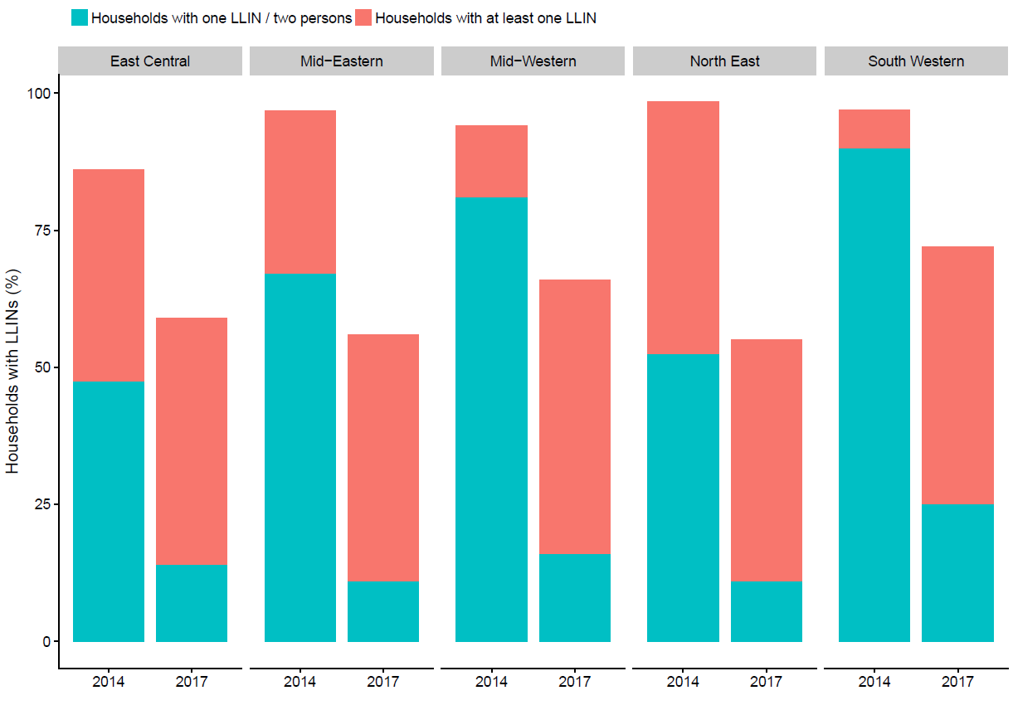

In 2017-18, Uganda conducted a second mass LLIN distribution campaign. Prior to this campaign, our group conducted a large cross-sectional survey of 5,200 households to estimate baseline LLIN coverage levels in 104 health sub-districts located in 48 districts, covering 5 of the 10 regions in the country [16]. Three years after the earlier LLIN campaign, we found that LLIN coverage levels had dropped substantially, with only 65% of houses owning at least one LLIN (down from 94% in 2014), and only 14% of households owning at least one LLIN per two residents (down from 65% in 2014, Figure 1).

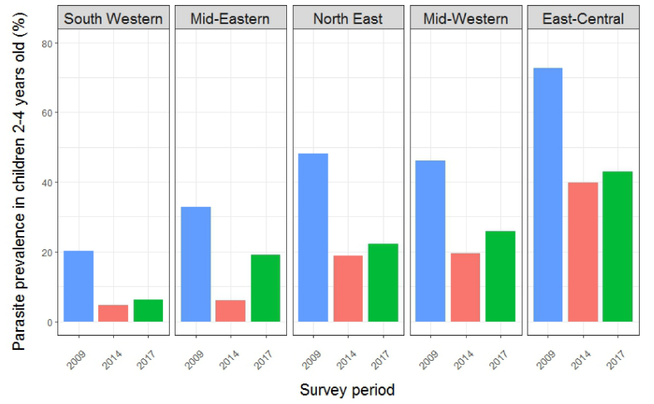

**Figure 2. Change in parasitaemia over time.** Parasitaemia in children 2-4 years fell from 46% in 2009 to 17% in 2014, but rose to 21% in 2017.

In 2017, we also conducted a clinical survey of parasite prevalence in children aged 2-10 years [17]. In total, 5,196 households and 8,834 children with blood smear results were included in the analyses. Overall, parasite prevalence was 26.0%, ranging from 8.0% in the South West to 53.1% in East Central. Limiting the analysis to children 2-4 years of age residing in the five regions, parasite prevalence was 21.4%. Comparisons made between the 2009 and 2014-15 Malaria Indicator Surveys and the 2017 survey (Figure 2) indicated that parasite prevalence fell from 45.6% to 16.9% between 2009 and 2014-15, with significant decreases in all five regions of the country (p<0.001 for all comparisons). However, in 2017, prevalence increased in all areas, which was statistically significant in the Mid-Eastern (6.0% vs. 19.1%, p<0.001) and Mid-Western regions (19.5% vs. 25.7%, p=0.02).

Thus, although the 2013-14 national LLIN distribution campaign successfully reached its target coverage level, we observed a limited effect on clinical malaria indicators and transient reduction in parasite prevalence. Moreover, LLIN coverage dropped substantially after 3 years. These findings highlight the challenges of relying on LLINs as the primary method of vector control in Uganda.

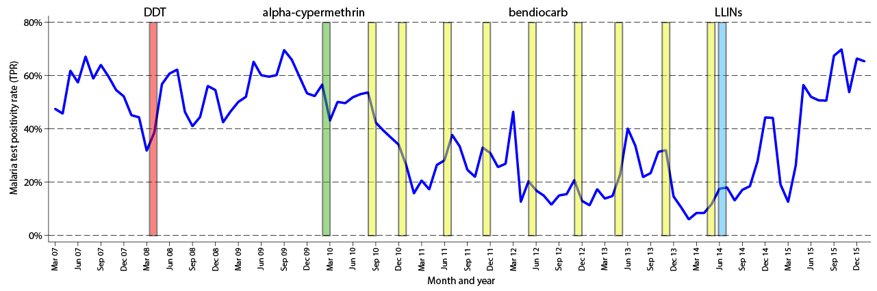

**Figure 3. Impact of vector control on malaria test positivity rate in Apac.** Monthly trends in malaria test positivity rate (TPR, blue line) in Apac following delivery of multiple rounds of IRS with different insecticides (red, green, yellow bars) and universal distribution of LLINs (light blue bar).

### 1.4 IRS in Uganda

IRS was adopted as a key component of Uganda’s malaria control strategy in 2006. Initial efforts were focused on epidemic-prone areas in the southwestern part of the country. However, in 2009, the IRS programme was moved to 10 high burden districts in northern Uganda. Initially organochlorine/pyrethroid insecticides were used for IRS, but the insecticide was changed to carbamates in 2010, due to the emergence of resistance to pyrethroids and DDT. The IRS programme in northern Uganda consistently achieved high coverage levels (above 95% of targeted households) and was associated with marked reductions in measures of malaria morbidity [18]. In 2014, the IRS program was withdrawn from the 10 northern districts and relocated to 14 new districts in north-eastern Uganda, with the hope that gains achieved by IRS in the north would be sustained by LLINs distributed after the last cycle of IRS. However, data from our health facility surveillance system showed that measures of malaria morbidity rose sharply within 4 months of the discontinuation of IRS, reaching pre-IRS levels (Figure 3) [19]. These data were instrumental in the decision to conduct one additional round of IRS in northern Uganda in 2017.

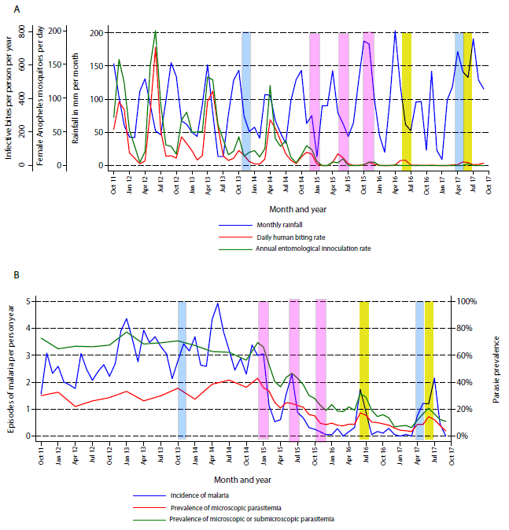

**Figure 4. Temporal changes in the entomologic and clinical malaria indicators from 2011 to 2017.** (4A) Monthly trends in daily human biting rates, annual entomologic inoculation rates, and rainfall. (4B) Monthly trends in symptomatic malaria, microscopic parasitaemia, and combined microscopic and sub-microscopic parasitaemia. Blue bars = LLIN distribution, Pink bars = IRS with bendiocarb, Yellow bars = IRS with pirimiphos-methyl *(Nankabirwa, et al, submitted for publication).*

The relocation of the IRS programme to north-eastern Uganda in 2014 allowed us to estimate impact of IRS in Nagongera sub-county, Tororo district. Since 2011, we have been following a cohort of households and carrying out entomology surveys through our PRISM project (Program for Resistance, Immunology, Surveillance, and Modelling of Malaria) (Figure 4). Our detailed longitudinal data have shown that repeated rounds of IRS have been temporally associated with dramatic reductions of daily human biting rates (a surrogate for malaria transmission, panel 4a) and malaria incidence (panel 4b). However, despite the overall reductions, malaria metrics increased just prior to each round of IRS, illustrating the fragile nature of the gains achieved.

Moreover, the prevalence of parasitaemia based on a highly sensitive measure (loop-mediated isothermal amplification [LAMP]) remained >10% after each round of IRS, demonstrating a persistent reservoir available to drive a resurgence in malaria transmission and cases, as occurred after IRS was withdrawn in the northern districts [20]. In Nagongera, we also observed a shift from *A. gambiae s.s.* as the primary vector to *A. arabiensis* after the start of IRS, which was also noted after the implementation of IRS in northern Uganda [21]. This shift in mosquito vectors could have important implications on the efficacy of other vector control interventions, such as LLINs, as *A. arabiensis* tends to bite earlier in the evening, and is more likely to feed on domestic animals, and to feed outdoors, than *A. gambiae s.s*. There are plans to continue the IRS program in the 14 districts in north-eastern Uganda. Spraying will be carried out annually using an appropriate chemical rotate at least every 3 years, in accordance with Uganda’s Insecticide Resistance Management (IRM) plan for control of malaria vectors in Uganda [22]. There is clear evidence that IRS has had a substantial impact on reducing the burden of malaria in Uganda. However, gains have been fragile, as evidenced by the resurgence of malaria when IRS was withdrawn in northern Uganda, and by the peaks in malaria metrics seen just prior to each round of IRS. New strategies to reduce transmission and sustainably maintain malaria control gains are needed to clear a pathway toward malaria elimination in Uganda.

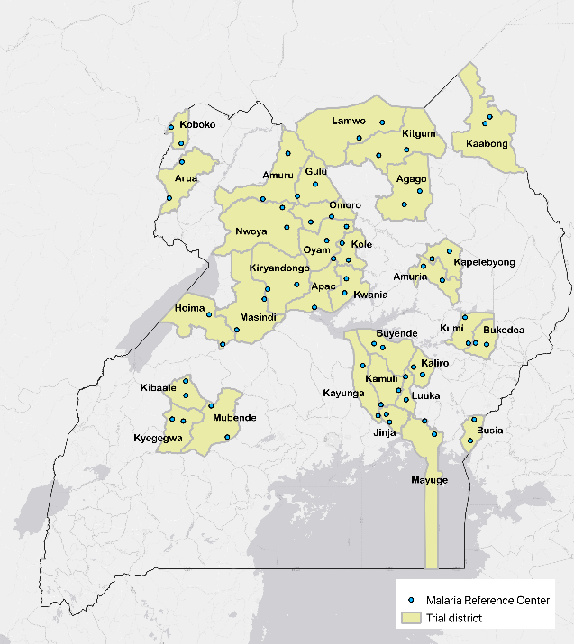

**Figure 5. Malaria reference centers in Uganda.** In total, 64 malaria reference centers (MRCs) cover 32 districts.

### 1.5 Health facility surveillance

In Uganda, the Health Management Information System (HMIS) is the primary source for malaria surveillance data. Aggregate data from all government-run and some private health facilities are assembled and reported at regular intervals using standardised registers and reporting forms. The introduction of the District Health Information System 2 (DHIS2), an electronic form of HMIS, in 2012, improved the collation of data at both the district and national level. DHIS2 is a web-based system with data from paper-based reports submitted to a central database. Despite improvements, concerns remain about the quality of HMIS data due to incomplete reporting, data entry errors, and reporting of malaria cases based on poor quality diagnostics or a lack of laboratory confirmation altogether. In addition, because the HMIS system relies solely on aggregate data, it is not amenable to stratification or subgroup analyses. Consequently, estimates of malaria morbidity may be biased, making it difficult to accurately monitor trends over time and space, or to measure the impact of control interventions. Despite these limitations, HMIS remains the only source of routine malaria surveillance data.

To improve the quality of malaria surveillance data, our group created the Uganda Malaria Surveillance Project (UMSP), in collaboration with the National Malaria Control Division, in 2006. The project initially included 6 health facilities, with individual level data collected electronically from all outpatients. Data are collected on patient demographics, laboratory test results, diagnoses, and treatments prescribed. The project has supported training in data management and high-quality laboratory testing (microscopy or malaria rapid diagnostic tests) on all patients with suspected malaria. In 2014, the programme expanded from 6 to 21 health facilities, and was expanded further to 35 sites in 2018-19. With funding support from the NIH, we expanded to 64 sites in 2020 (Figure 5). Health facilities selected for our malaria surveillance network are referred to as Malaria Reference Centers (MRCs) and provide a wide geographic scope across Uganda. The primary metrics used to monitor trends from our malaria surveillance network have been the number of laboratory confirmed cases of malaria and the test positivity rate (number of confirmed cases of malaria / number of suspected cases undergoing laboratory testing). However, these metrics do not provide a direct measure of the burden of malaria in defined populations at risk. To address this limitation, we have developed a method to estimate the incidence of malaria in catchment areas around the health facilities.

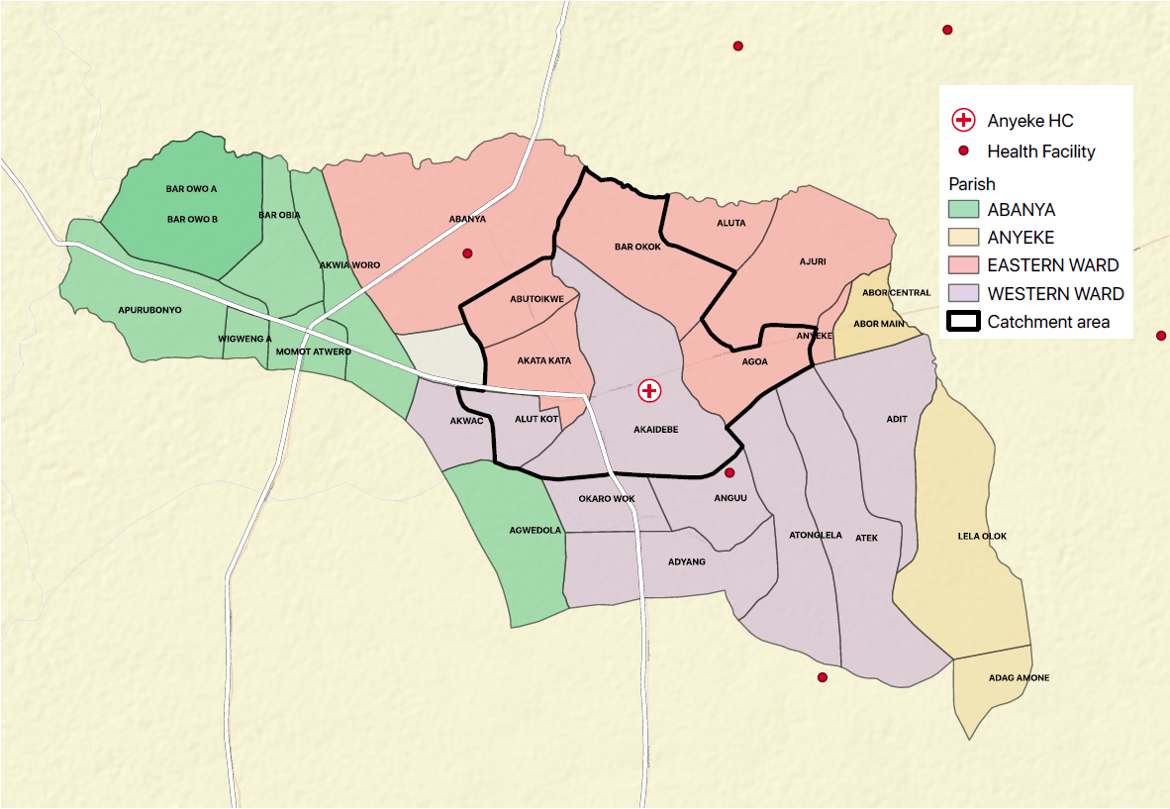

**Figure 6. Map of Anyeke MRC catchment area.**

To accomplish this, we began collecting data on village and parish of residence for all patients presenting to the health facilities in 2017. To generate maps of villages around the MRCs, a preliminary map was made using a list of villages obtained from the government and shape files that are publicly available. The GPS coordinates of each MRC were then verified and the names and shape files for all villages of interest were confirmed. A final clean version of the map was printed and shared with the MRC to help improve the quality of the data collection (Figure 6).

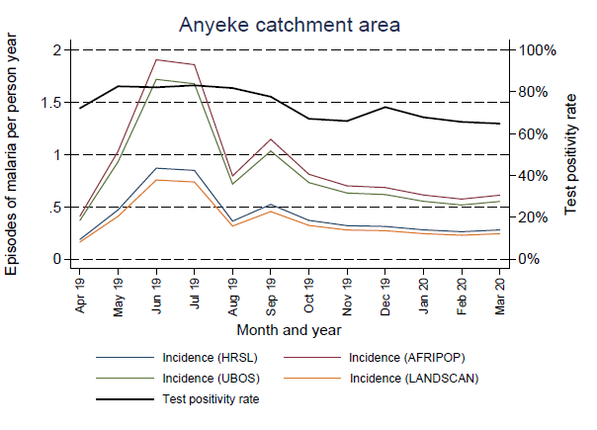

**Figure 7. Estimating malaria incidence at the Anyeke MRC.** Anyeke MRC test positivity rate and malaria incidence by month from April 2019 to March 2020, with incidence estimates calculated using four different sources) to estimate the population of the catchment area.

Using population estimates for MRC catchment areas, and assuming all care for malaria within the catchment areas occurs at the health facility (a reasonable assumption in rural Uganda), we are able to generate estimates of malaria incidence, defined as the number of cases of laboratory confirmed malaria diagnosed at the health facility among patients residing in the catchment area per unit time / the population of the catchment area. For the numerator, the total number of malaria episodes from the MRC catchment area during the time of interest is calculated as the sum of the following: laboratory confirmed malaria cases, plus the estimated number of cases of suspected malaria with no test results, pus the estimated number of cases of laboratory confirmed malaria cases with missing information on village of residence. For the denominator, four population databases have been consulted, including High Resolution Settlement Layer (HRSL), Uganda Bureau of Statistics (UBOS), the AfriPop project (AFRIPOP), and Oak Ridge National Laboratory’s LandScan (LANDSCAN) (Figure 7). In the future, we plan to conduct a census survey of each MRC catchment area to confirm the population. By establishing the capacity to estimate malaria incidence for the catchment areas of the MRCs, we have built a platform which will allow us to assess the impact of LLINs distributed through the national LLIN campaign on malaria incidence on a widescale.

### 1.6 Insecticide resistance

Resistance against all classes of insecticides has been observed in the primary African malaria vectors *A. gambiae s.s.*, *A. arabiensis,* and *A. funestus* [23]. In African Anopheles mosquitoes, pyrethroid resistance is primarily mediated through two mechanisms; ‘knock down resistance’ (*kdr*) caused by mutations in the voltage-gated sodium channel where pyrethroids bind, and metabolic resistance resulting from alterations in enzymes that detoxify pyrethroids, notably cytochrome P450s.[24, 25] Since *kdr* mutations were first documented in Ugandan *A. gambiae s.s.* and *A. arabiensis* in 2001, pyrethroid resistance has continued to spread [26, 27]. In our 2017 survey of 5,200 households in 48 districts of Uganda, entomological sampling was carried out in a sub-set of 1029 households [4]. The *kdr* mutation *Vgsc-L1014S* was found at very high frequency in *An. gambiae s.s*. with the wild-type allele virtually absent. The alleles *Cyp4j5-L43F* and *Coeae1d*, associated with metabolic resistance, were found at moderate frequencies which varied across the study site (Figure 8).

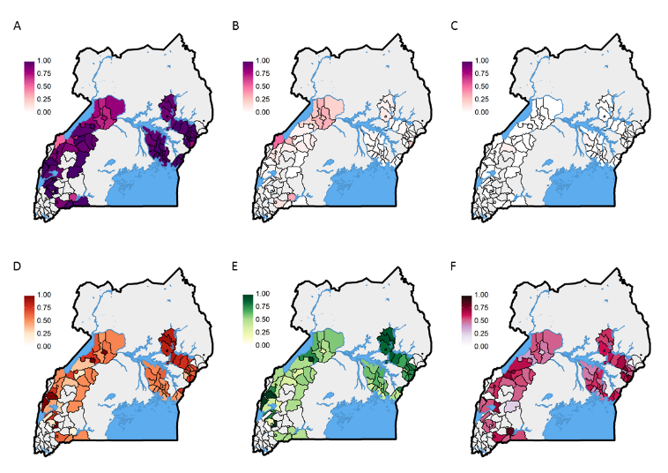

**Figure 8. Resistance and allele frequencies in *An gambiae s.s*.** A) Vgsc-1014S, B) Vgsc-1014F, C) Vgsc-1014L, D) Cyp4j5-L43F, E) 2La inversion, F) Coeae1d.

Evidence suggests that insecticide resistance is contributing to sub-optimal vector control in Uganda [18], and across sub-Saharan Africa [28]. Phenotypic data from our PRISM project showed high-level resistance to pyrethroids among *A. gambiae* and *A. arabiensis* at 3 sites (Figure 9), which was associated with limited impact of LLINs [15].

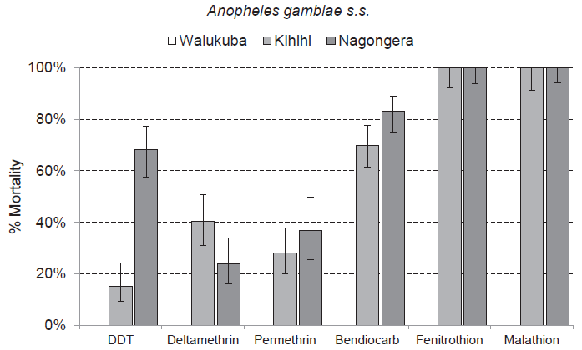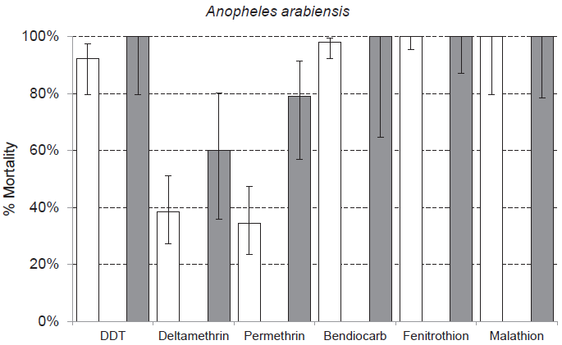

**Figure 9. Insecticide resistance monitoring in Jinja (Walukuba sub-county), Kanungu (Kihihi) and Tororo (Nagongera).**

24-hour mortality levels with 95% standard error bars for Anopheles gambiae s.s. (Kihihi and Nagongera only) and Anopheles arabiensis (Walukuba and Nagongera only) exposed for one hour to insecticide-treated papers impregnated with WHO diagnostic concentrations of insecticides. By WHO convention mortality of 98–100% indicates susceptibility; <98% is suggestive of resistance, and <90% is strongly suggestive of resistance.

### 1.7 LLINs treated with piperonyl butoxide

Currently, all conventional LLINs are impregnated with pyrethroid insecticides, due to their favourable safety profile, low cost and rapid insecticidal activity [29]. However, malaria control efforts are threatened by pyrethroid resistance [30], and newer LLINs treated with more than one agent are being developed [31]. One new LLIN incorporates pyrethroids with a synergist, piperonyl butoxide (PBO), which inhibits P450s enzymes, thus blocking one other major resistance mechanism and partially restoring pyrethroid susceptibility [32]. This strategy is supported by bioassays conducted by our group showing near complete recovery of pyrethroid susceptibility in Ugandan anophelines [33]. LLINs with PBO are anticipated to be more effective in areas where pyrethroid resistance is mediated at least partially by P450 enzymes. However, the effectiveness of PBO LLINs is expected to vary according to local resistance patterns and transmission intensity, as well as net characteristics.

A systematic review of PBO LLINs found that they were associated with higher mosquito mortality and lower blood-feeding rates in areas of high-level insecticide resistance, as compared to non-PBO LLINs [34]. A cluster-randomised, clinical trial of the effectiveness of a PBO LLIN (Olyset Plus), conducted in Tanzania, found that PBO LLINs were associated with lower parasite prevalence, than conventional LLINs, at 9, 16, and 21 months after distribution [35]. Subsequently, the WHO issued an interim endorsement of PBO LLINs, recommending them for areas of intermediate-level pyrethroid resistance, due at least partly to metabolic mechanisms [36]. However, the Tanzanian study had several limitations: the study was restricted to one district; parasite prevalence was measured using rapid diagnostic tests, which may have variable specificity [37], insecticide resistance was assessed by *kdr* mutations, not markers of metabolic resistance; and 21-month data were potentially compromised by routine distribution of new LLINs within the study area.

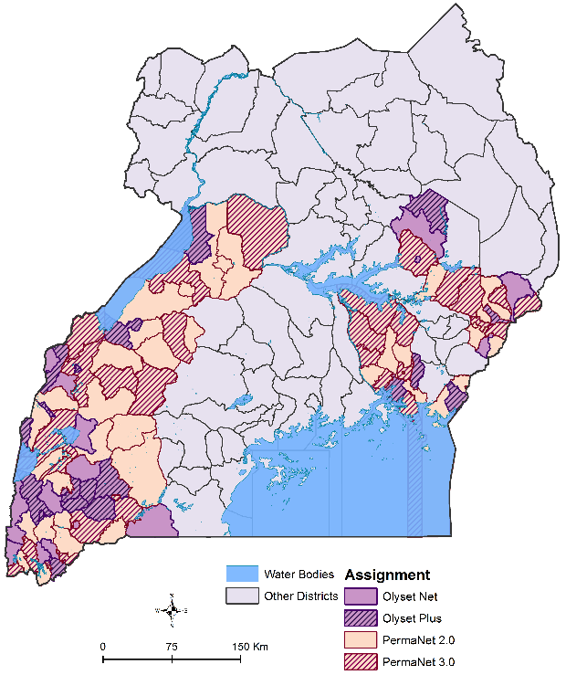

**Figure 10. Map of LLINEUP study sites.** In total, 104 health sub-districts (clusters) from 48 districts were included.

### 1.8 LLINEUP trial

In 2017-18, the Ugandan Ministry of Health distributed LLINs with, and without, PBO through a national mass-distribution campaign, providing a unique opportunity to rigorously evaluate PBO LLINs across different epidemiological settings. In close collaboration with the Ministry of Health, we embedded a cluster-randomised trial to evaluate the impact of the LLINs delivered in the 2017-18 national campaign at an unprecedented scale in Eastern and Western Uganda. Overall, 104 clusters (health sub-districts) were included, covering 40% of Uganda (Figure 10) [38]. Proportionate randomisation was used to assign clusters to one of four arms, including LLINs with PBO (32 PermaNet 3·0, 20 Olyset Plus), and conventional LLINs (37 PermaNet 2·0, 15 Olyset Net). At baseline, 6, 12, 18 and 25 months after LLIN distribution, cross-sectional surveys were conducted in 50 randomly selected households per cluster (5,200 per survey); a sub-set of 10 households per cluster (1,040 per survey) were randomly selected for entomology surveys. The primary outcome was parasite prevalence by microscopy in children aged 2-10 years.

Baseline surveys were conducted in 2017 [4, 16, 17]. LLINs were delivered from March 2017 to March 2018. In the ‘as treated’ analysis, three clusters were excluded because no predominant LLIN was received, and four clusters were reassigned, resulting in 49 PBO LLIN (31 PermaNet 3.0, 18 Olyset Plus) and 52 non-PBO LLIN clusters (39 PermaNet 2.0, 13 Olyset Net). At six months, parasite prevalence was 10.7% in the PBO arm vs 14.5% in the non-PBO arm (prevalence ratio [PR] adjusted for baseline values 0.74, 95% CI: 0.62–0.87, p<0.001). Results were similar at 12 months (10.6% vs 13.0%, PR 0.73, 95% CI: 0.63–0.85, p<0.001) and at 18 months (11.8% vs 14.0%, PR 0.84, 95% CI: 0.72–0.98, p=0.03). In the 90 clusters for which follow-up data were available at 25 months (42 PBO vs 48 non-PBO), parasite prevalence remained lower in the PBO arm than the non-PBO arm (17.1% vs 19.8%, PR 0.80, 95% CI: 0.69–0.93, p=0.005). Although overall parasite prevalence at 25 months was trending upward, it remained significantly lower than at baseline (18.6% vs 27.0%, PR 0.71, 95% CI: 0.67–0.77, p<0.001), which was true for both PBO and non-PBO clusters. Thus, in the LLINEUP trial, we found that PBO LLINs provided superior protection against malaria in the setting of high-level insecticide resistance in Uganda. This innovative trial, embedded within a national LLIN distribution campaign, serves as a paradigm for future assessment of malaria control interventions, including the trial proposed here.

### 1.9 Dual active-ingredient LLINs with pyriproxyfen

Other next generation LLINs combine a pyrethroid insecticide with a second active ingredient, such as pyriproxyfen [39-41]. Treating LLINs with a combination of insecticides with different modes of action may improve efficacy, and help to prevent or delay the spread of insecticide resistance. Pyriproxyfen (PPF) is an insect growth regulator, which has traditionally been used as a larvicide [42, 43], but also acts as a sterilizing agent, reducing the fecundity (egg laying), fertility (production of viable offspring), and longevity of adult mosquitoes [44-48]. PPF has a different mechanism of action than pyrethroids and other commonly used insecticides, is effective at very low concentrations, and has been demonstrated to be safe to humans [42, 49]. In theory, pyrethroid-resistant mosquitoes that survive initial contact with a PPF-treated LLIN would be sterilized by the PPF. Thus, a dual active-ingredient LLIN including PPF is an attractive option.

In initial experimental hut trials conducted in Benin and Cote d’Ivoire, LLINs treated with the pyrethroid permethrin and PPF (Olyset Duo, Sumitomo Chemical) were associated with higher mosquito mortality and reduced blood-feeding rates, compared to standard LLINs treated with permethrin only (Olyset Net) [41, 50]. Moreover, surviving mosquitoes exposed to PPF-treated nets had substantially lower fecundity and fertility rates [39, 50]. In Kenya, a field trial comparing permethrin + PPF nets (Olyset Duo) to permethrin-only LLINs (Olyset Net) and a PPF-only treated net showed similar sterilizing effects against wild pyrethroid-resistant *An gambiae s.s.* [40]. In a step-wedge, cluster-randomised trial conducted in Burkina Faso, permethrin + PPF LLINs (Olyset Duo) were associated with lower clinical incidence in children aged 6-59 months than permethrin-only LLINs (Olyset Net) (1.5 vs 2.0 episodes per child-year, incidence rate ratio 0.88, 95% CI 0.77-0.99, p=0.04) [51]. The entomologic inoculation rate was also lower in the permethrin + PPF LLIN arm compared to permethrin-only LLINs (42 vs 85 infective bites per transmission season, rate ratio 0.49, 95% CI 0.32-0.66, p<0.0001). The PPF-treated LLINs appeared to work by reducing the vector population density and lifespan of adult mosquitoes, thus reducing the number of infective bites [51]. Another study from Burkina Faso found that the bio-efficacy and durability of PPF-treated LLINs (Olyset Duo) was superior to permethrin-only LLINs (Olyset Net) but that net survivorship for both net types was poor at 36 months [52]. The World Health Organization has pre-qualified one dual active-ingredient LLIN, which is treated with both a pyrethroid (alpha-cypermethrin) + PPF (Royal Guard LLIN, which produced by Disease Control Technologies) [53]. PPF-treated dual active-ingredient LLINs are promising, but additional epidemiologic studies in different settings are needed.

# 2 Rationale

LLINs provide the foundation for vector control in Uganda, and elsewhere in Africa. However, the effectiveness of LLINs is threatened by widespread pyrethroid resistance. In the first LLINEUP trial, we found that PBO LLINs were superior to conventional LLINs [54]. However, PBO LLINs have several potential limitations. PBO is a synergist, not an insecticide, and can only restore sensitivity of pyrethroid insecticides if resistance is due to specific metabolic mechanisms. Moreover, PBO cannot fully restore susceptibility in all resistant mosquito populations. Newer dual active-ingredient LLINs treated with a combination of insecticides using different modes of action are attractive alternatives; these LLINs may provide greater protection and delay the spread of insecticide resistance, but like PBO LLINs, they are more expensive than conventional nets. Further evidence of the effectiveness and cost-effectiveness of PPF-treated LLINs is urgently needed. Royal Guard LLINs, treated with alphacypermethrin and PPF, are one of only two dual active-ingredient LLINs prequalified by the WHO [53], which are available for widescale distribution.

In Uganda, the National Malaria Control Division (NMCD) and implementing partners are planning to deliver LLINs nationwide in 2020, through a mass distribution campaign supported by generous contributions from international donors. LLINs will be distributed free-of-charge to all Ugandan households, aiming to achieve universal coverage. The Against Malaria Foundation has agreed to provide LLINs treated with a pyrethroid insecticide plus PPF (Royal Guard, Disease Control Technology) and LLINs treated with a pyrethroid insecticide plus PBO (PermaNet 3.0, Vestergaard), presenting an opportunity to rigorously evaluate and compare these two LLINs at scale across Uganda. In collaboration with the MOH, we propose to embed a cluster-randomised trial to compare the impact of LLINs with PPF to LLINs with PBO into Uganda’s 2020 LLIN distribution campaign, as we did successfully for the last LLIN distribution campaign conducted in 2017-18.

A major strength of the proposed trial is the use of malaria incidence as the primary outcome measure. Incidence of malaria, defined as the number of symptomatic cases of malaria occurring in a population at risk over time, is the gold standard for assessing malaria burden. However, cluster-randomised trials using malaria incidence as the primary outcome are very expensive and logistically challenging. A novel approach for measuring malaria incidence, which we have proposed here, is to utilize data collected routinely at health facilities. By defining catchment areas around health facilities and collecting data on the location of residence of patients diagnosed with malaria, we will be able to generate longitudinal measures of malaria incidence at an unprecedented scale across Uganda.

Finally, there is an urgent need to better understand the potential impact of the COVID-19 pandemic on malaria in Uganda. To our knowledge, no published studies have evaluated how malaria control and care have evolved in Uganda since the onset of the COVID-19 pandemic. This is partly because of limited testing available for SARS-CoV-2, particularly in rural communities where the burden of malaria is highest. Given the platform provided by the MRC surveillance, we are uniquely poised to evaluate the association between malaria and evidence of prior exposure to COVID-19 across Uganda. These results will inform policies and programmes for both malaria and COVID-19 in Uganda.

# 3 Study objectives

We propose to address the following research question: *Are LLINs treated with a pyrethroid insecticide plus pyriproxyfen (PPF LLINs) more effective than LLINs treated with a pyrethroid plus piperonyl butoxide (PBO LLINs) for malaria control in Uganda, particularly in high-burden areas?*

The primary objective of the study is: *To evaluate the impact of LLINs treated with a pyrethroid insecticide plus pyriproxyfen (PPF LLINs), as compared to LLINs treated with a pyrethroid plus piperonyl butoxide (PBO LLINs), on malaria incidence in Uganda.* We will test the hypothesis that malaria incidence will be lower in intervention clusters (randomised to receive PPF LLINs) than in control clusters (randomised to receive PBO LLINs).

In addition, the following secondary objectives will be addressed:

1. *To evaluate the impact of PPF LLINs, as compared to PBO LLINs, on parasite prevalence, prevalence of anaemia, and malaria vector density.* We will test the hypothesis that parasite prevalence, prevalence of anaemia and malaria vector density will be lower in intervention clusters (PPF LLINs), than in control clusters (PBO LLINs).
2. *To estimate the cost-effectiveness of delivering PPF LLINs, as compared to PBO LLINs.* We will estimate incremental cost-effectiveness ratios (USD per disability-adjusted life year averted and per malaria case averted).
3. *To assess net durability, bio-efficacy, survivorship and use of PPF LLINs vs PBO LLINs in Uganda.* We will conduct cross-sectional surveys to determine net survivorship, attrition and use, and will supplement these with laboratory assessments of net durability and bio-efficacy.
4. *To assess the impact of COVID-19 on malaria burden and care.* Through our cross-sectional surveys, we will estimate malaria parasite prevalence and seroprevalence of antibody responses to selected SARS-CoV-2 antigens, suggestive of prior infection with COVID-19, in individuals of all ages.

# 4 Study design & methods

### 4.1 Overview

We propose to conduct a rigorous, cluster-randomised trial to evaluate the impact of LLINs distributed in Uganda through the 2020 national universal coverage campaign. A cluster has been defined as the catchment area of an MRC. A total of 64 clusters have been included in the study, covering 32 high malaria burden districts in Uganda where IRS is not being implemented. Clusters have been randomised in a 1:1 ratio in blocks of two by district to receive one of two types of LLINs: (1) PPF LLINs (Royal Guard [n=32] and (2) PBO LLINs (PermaNet 3.0) [n=32] (Appendix A).

The intervention, including delivery of the LLINs and social and behaviour change communication (SBCC), will be led by the Ugandan NMCD and other stakeholders. Currently, LLINs are scheduled to be delivered in the study areas from September to November 2020. The evaluation will include health facility surveillance at the MRCs to generate continuous estimates of malaria incidence for each MRC catchment area, cross-sectional community surveys at baseline (if additional resources are available), and at 12- and 24-months after LLIN distribution to gather information on net survivorship and use, and parasite prevalence in children 2-10 years of age, entomology surveys, and assessment of net durability and efficacy. The primary outcome of the trial will be malaria incidence as estimated using the health facility surveillance. In 32 selected clusters (one per district), parasite prevalence and the seroprevalence of COVID-19 will be assessed in individuals of all ages from participating households.

For each cluster we will use a ‘fried egg’ approach for delivering the intervention (‘egg white’) and measuring our outcomes (‘egg yolk’). The ‘white’ of the egg will include one sub-county per cluster, where the MRC is located. PPF LLINs and PBO LLINs will be distributed to the designated sub-county, as allocated in the randomisation. The ‘yolk’ of the egg will be the catchment area directly surrounding each MRC, where care-seeking at the MRC is expected to be high (i.e. if someone within the catchment area develops malaria, they are likely to seek care at the MRC). To determine the population of the MRC catchment areas, and to generate a sampling frame for the community surveys, we will do the following: (1) define the catchment area of each MRC before the onset of the trial using data on village of residence from patients attending the MRCs, (2) map and enumerate all households within the MRC catchment areas before the 12-month community survey, (3) conduct a census survey within each MRC catchment area to generate an accurate estimate of the study population in which study outcomes will be measured concurrently with the 12-month community survey.

The study will be conducted over approximately 2.5 years (30 months) from October 2020 to April 2023. The field work in Uganda will be led by IDRC, with oversight from the University of California, San Francisco (UCSF), and support from the London School of Hygiene & Tropical Medicine (LSHTM) and Liverpool School of Tropical Medicine (LSTM).

### 4.2 Study sites

The NMCD and supporting partners will distribute LLINs nationwide across Uganda, including the 32 districts included in this study. Districts were selected to participate in the study based on the following criteria: (1) Not receiving IRS, (2) Selected by the NMCD to receive PBO LLINs, based on available insecticide resistance data and guided by Uganda’s insecticide resistance management plan [22], (3) high malaria transmission intensity. Once the districts were identified, we then selected MRCs to bring the total to 64.

The selection criteria for the LLINEUP2 MRC sites, included: (1) Level III/IV high-volume, public health facility (HC III or HC IV), (2) Total OPD attendance between 1000-2000 patients per month, (3) Evidence of weekly and monthly reporting in DHIS2, (4) Presence of a functional laboratory at the facility. In addition, we aimed to ensure that MRCs within the same district were comparable in terms of level-of-care, and were located in different sub-counties to avoid contamination.

### 4.3 Randomisation

Given the open-label study design and the need to generate estimates of the targeted number of LLINs for distribution in advance, randomisation was completed at the time of the protocol development. The randomisation was carried out by a member of the study team who is not based in Uganda, and who will not be directly involved in the field work. The unit of randomisation (cluster) was at the level of the MRC and the surrounding sub-county targeted for LLIN distribution. Randomization was done in blocks of 2, with each block representing a district containing 2 clusters with one cluster assigned the letter “A” and one cluster assigned the letter “B”. For each block, a random number between 0 and 1 was generated using the ‘runiform’ command in STATA (StataCorp, Texas, USA). If the random number was <0.5, cluster “A” was assigned to PBO LLINs and cluster “B” was assigned PPF LLINs. If the random number was >0.5, cluster “A” was assigned to PPF LLINs and cluster “B” was assigned PBO LLINs. The final treatment allocations are summarized in Table 1, and the full intervention allocation list is provided in Appendix A.

**Table 1. Allocation of LLINs**

|  |  |  |
| --- | --- | --- |
| **Type of LLIN** | **Targeted total number of LLINs for distribution** | **Number of clusters allocated** |
| PPF LLIN | 632,359 | 32 |
| PBO LLIN | 696,914 | 32 |
| **Total** | **1,329,273** | 64 |

### 4.4 Sensitisation

Prior to starting the study, we plan to build awareness, secure commitment, and encourage participation from stakeholders at the national and sub-national levels. We will engage with members of the Ugandan Ministry of Health in Kampala, and other key stakeholders including representatives from the US President’s Malaria Initiative (PMI), the World Health Organisation (WHO), and the UK’s Department for International Development (DFID). We will also engage with key stakeholders and opinion leaders at the district and community level in participating districts, including the LC V chairpersons, Chief Administrative Officers, District Health Officers and Malaria Focal Persons, local council chairmen (LCIs), village health team (VHT) members, health care workers and religious leaders. Study personnel will use a standard information sheet (Appendix B) to help guide sensitisation discussions.

### 4.5 Enumeration survey

To estimate the population of the MRC catchment areas, and to generate a sampling frame for the 12-months cross-sectional community survey, we will enumerate and map all households within each catchment area prior to the evaluation (Figure 6). In advance of the survey, investigators will meet with local officials and community representatives to discuss the study and plans for the household enumeration. Using a map of the boundaries of the MRC catchment areas, project personnel will systematically cover the entire area within the boundaries to identify and enumerate all households.

A household will be defined as any single permanent or semi-permanent dwelling structure acting as the primary residence for a person or group of people that generally cook and eat together. Some households may include members who sleep in other dwelling structures within the same compound, if the members are still dependent on the head of household in the main household.All households identified will be assigned sequential unique IDs. Household locations will be mapped using GPS receivers. Readings will be taken from the door of the household, if possible, or from a point that is most representative of the household. At each household, a reading will be taken every five seconds for 2 minutes, and the average values from these readings will be recorded (Easting, Northing, and Altitude) in UTM units. Only GPS coordinates will be picked from the households. No additional data will be collected during the enumeration survey.

# 5 Intervention

The NMCD and other stakeholders will take the lead on delivering the LLINs in the 32 districts included in the study. The research team will only be responsible for carrying out the evaluation. Here, the plans for the net distribution campaign are described to provide background information on the intervention. The original timelines for the 2020 LLIN distribution campaign have been delayed by COVID-19 pandemic, and the government’s response to prevent transmission and spread of COVID-19.

### 5.1 Overview

The LLINs will be distributed according to detailed national guidelines, which build on prior experience from a similar net distribution campaigns carried out in 2013-2014 and 2017-18, incorporated guidance for LLIN distribution in the context of COVID-19, and lessons from food distribution during COVID-19. The overall goal of the 2020 LLIN distribution campaign is to reduce malaria morbidity and mortality in Uganda by achieving universal coverage with LLINs, aiming to ensure that: (1) 85% of the targeted population has access to a LLIN, and (2) 85% of LLINs distributed are utilised. Members of the research team will engage with Uganda’s national committees that are coordinating the LLIN universal coverage campaign, including the National Coordination Committee (NCC), which will be responsible for overall coordination and oversight of campaign planning, implementation, and engagement with political and traditional authorities, the operations sub-committee, the logistics sub-committee and the advocacy, communication and social mobilisation sub-committee. All LLINs procured for the campaign will be stored centrally in at the National Medical Stores warehouses in Entebbe and will be distributed across the country in waves. The 32 districts selected for this study are included in Waves 3-5 and are scheduled to receive nets from October 2020 to February 2021, although the timelines are subject to change depending on procurement and importation of the LLINs. The research team will work closely with the NCC and other stakeholders to ensure that the nets are allocated per the randomisation scheme.

### 5.2 Household registration and LLIN distribution

A key aspect of the distribution will be to ensure that the community members receive the correct number of LLINs. The LLINs will be stored centrally at the National Medical Stores warehouses in Entebbe, and then transferred from the central location to sub-county stores, and then onward to the household. A ‘door to door’ model of LLIN delivery will be applied with registration and LLIN distribution carried out concurrently. The processes will be handled by a multidisciplinary team, comprised of 5 individuals including: village health team member (VHT)/data clerk, security personnel, Local Council 1 (LC1), and two LLIN carriers. On average, there will be two teams per village for rural settings and four teams per village for urban settings, including towns and municipalities.

The Electronic Data Management Information System (EDMIS) will be used for data management including the following: (1) collection of household-level registration data; (2) establishment of household LLIN need; (3) allocation of number of LLINs for each household; and (4) assignment of household Chalk ID. The VHTs/data clerk will interview the head of household if available, or another adult resident, using the EDMIS electronic system. Information collected will include: (1) name of the household head; (2) National ID number of the head of household; (3) number of residents; (4) number of children under 5 years of age; (5) number of pregnant women; (6) sleeping places available; and (7) the telephone number for the household (if available). The EDMIS electronic system will then generate the Chalk ID and allocate LLINs automatically for each household based on the registration data. The assigned Chalk ID will be written on the household and the allocated LLINs issued to the head of household, or another adult resident, immediately. The household LLIN distribution will be based on household population with one LLIN distributed for every two people living in the household. The recipient of the LLINs will acknowledge receipt using an appropriate method.

### 5.3 Social behaviour change communication

The NMCD and other stakeholders will take the lead on Social Behaviour Change Communication (SBCC). The UMIS 2018 showed that over 43% of the LLINs in the country were not being used. Thus, a comprehensive SBCC campaign is planned to increase LLIN utilization, with the campaign branded ‘*under the net 2020-2022*’. SBCC activities will use digital and other platforms, similar to those used for the COVID-19 response, including the following: (1) LLIN launch on television and radio; (2) regional advocacy meetings on Zoom; (3) mass media platforms (for advertisements, mini skits, DJ mentions, radio spots, interactive talks); (4) social media platforms; (5) VHTs; (6) operation hotlines and toll-free call centres; (7) community mobilisation (megaphones); and (8) use of appropriate information, education, and communication materials. Communication will include messages about COVID-19, malaria, and use, care, repair and repurposing of LLINs.

# 6 Health facility surveillance

### 6.1 Data collection at MRCs

At each MRC, individual-level data from standardised registers for all patients presenting to the outpatient departments are entered into an Access database by on-site data entry officers. Primary data captured comes from the HMIS 002 standardised form (Appendix C) and includes location of residence (parish and village), age, gender, body temperature, history of subjective fever, type of malaria test done (rapid diagnostic test or microscopy), malaria diagnostic test results, any diagnoses given, and any treatments prescribed. The research team supports the sites with training, site support supervision, and buffer stock of laboratory supplies/consumables. We employ full-time regional surveillance coordinators based around the country, each supervising 8-10 MRCs. Team members based in Kampala include the programme manager, several study epidemiologists, a data manager, a laboratory manager, and administrative staff. Members of the core team visit the MRCs on a regular basis to provide refresher training and feedback, and to conduct laboratory quality control procedures. Core team members are also responsible for generating periodic reports, communicating with MOH officials and other key stakeholders, and conducting data analyses.

**Table 2. Malaria reference centers**

|  |  |  |  |  |  |  |  |
| --- | --- | --- | --- | --- | --- | --- | --- |
|  | **District** | **MRC 1** | **Sub-county** | **Start date** | **MRC 2** | **Sub-county** | **Start date** |
| 1 | Agago | Patongo HCIII | Patongo TC | Aug 14 | Lira-Kato HCIII | Lapono | Oct 19 |
| 2 | Amuru | Atiak HCIV | Attiak | Sep 14 | Amuru HCIII | Amuru | Nov 19 |
| 3 | Gulu | Awach HCIV | Awach | Aug 14 | Pabwo HCIII | Bungatira | Oct 19 |
| 4 | Kitgum | Namokora HCIV | Namokora | Sep 14 | Kitgum Matidi HCIII | Kitgum Matidi | Nov 19 |
| 5 | Koboko | Lobule HCIII | Lobule | Aug 18 | Ayipe HCIII | Kuluba | Dec 19 |
| 6 | Kole | Aboke HCIV | Aboke | Mar 14 | Bala HCIII | Bala | Nov 19 |
| 7 | Lamwo | Padibe HCIII | Padibe | Sep 14 | Madi-Opei HCIII | Madi-Opei | Nov 19 |
| 8 | Arua | Opia HCIII | Vurra | Sep 14 | Cilio HCIII | Aii-vu | Dec 19 |
| 9 | Nwoya | Koch Goma HCIV | Koch Goma | May 19 | Alero HCIII | Alero | Jan 20 |
| 10 | Omoro | Lalogi HCIV | Lalogi | Sep 14 | Bobi HCIII | Bobi | Jan 20 |
| 11 | Oyam | Anyeke HCIV | Oyam TC | Apr 14 | Otwal HCIII | Otwal | Nov 19 |
| 12 | Amuria | Asamuk HCIII | Asamuk | Nov 19 | Morungatuny HCIII | Morungatuny | Dec 19 |
| 13 | Bukedea | Bukedea HCIV | Bukedea | Nov 19 | Kolir HCIII | Kolir | Nov 19 |
| 14 | Kumi | Kamaca HCIII | Kanyum | Jan 20 | Omatenga HCIII | Kumi | Nov 19 |
| 15 | Apac | Teboke HCIII | Chegere | Feb 20 | Akokoro HCIII | Akokoro | Feb 20 |
| 16 | Busia | Lumino HCIII | Lumino | Jun 18 | Busitema HCIII | Busitema | Mar 20 |
| 17 | Jinja | Budondo HCIV | Budondo | Jan 20 | Butagaya HCIII | Butagaya | Jan 20 |
| 18 | Kapelebyong | Kapelebyong HCIV | Kapelebyong | Nov 19 | Obalanga HCIII | Obalanga | Jan 20 |
| 19 | Kwania | Aduku HCIV | Aduku TC | Oct 06 | Apwori HCIII | Chawente | Nov 19 |
| 20 | Kaliro | Bumanya HCIV | Bumanya | Dec 19 | Nawaikoke HCIII | Nawaikoke | Feb 20 |
| 21 | Luuka | Kiyunga HCIV | Luuka TC | Dec 19 | Ikumbya HCIII | Ikumbya | Jan 20 |
| 22 | Masindi | Bwijanga HCIV | Bwijanga | Dec 19 | Kyatiri HCIII | Pakanyi | Dec 19 |
| 23 | Mayuge | Buwaiswa HCIV | Buwaya | Jan 20 | Kigandalo HCIV | Kigandalo | Feb 20 |
| 24 | Kiryandongo | Diima HCIII | Mutunda | Mar 20 | Kigumba HCIII | Kigumba | Feb 20 |
| 25 | Buyende | Kidera HCIV | Kidera | Feb 20 | Bugaya HCIII | Bugaya | Feb 20 |
| 26 | Kaabong | Lokolia HCIV | Kaabong East | Jul 18 | Kalapata HCIII | Kalapata | Feb 20 |
| 27 | Hoima | Kigorobya HCIV | Kigorobya TC | Feb 18 | Butema HCIII | Buhanika | Feb 20 |
| 28 | Kibaale | Kibaale HCIV | Kibaale TC | May 18 | Kyebando HCIII | Kyebando | Feb 20 |
| 29 | Kyegegwa | Kakabara HCIII | Kakabara | Jan 20 | Kyegegwa HCIV | Kyegegwa TC | Mar 20 |
| 30 | Kayunga | Bbaale HCIV | Bbaale | Feb 18 | Kangulumira HCIV | Kangulumira | Mar 20 |
| 31 | Mubende | Kasambya HCIII | Kasambya | Dec 06 | Kiyuni HCIII | Kiyuni | Feb 20 |
| 32 | Moyo | Metu HCIII | Metu | Sept 20 | Lefori HCIII | Lefori | Sept 20 |

Data will be collected for all patients presenting to the outpatient departments of the MRCs using the HMIS 002 outpatient register as the primary data source. Data from registers will be entered into customised electronic databases on site (Appendix D). Plans for management of the MRC data are described further in section 11.1.

# 7 Cross-sectional surveys

### 7.1 Overview

We propose to conduct cross-sectional community surveys at baseline (if resources are available), and at 12- and 24-months after LLIN distribution. The sampling frame for the community surveys will be generated from the enumeration of the MRC catchment areas (which will be conducted prior to the onset of the evaluation). Households will be randomly selected from each of the 64 clusters and screened until 50 households with at least one child aged 2-10 years are enrolled (total 3,100 households). The cross-sectional community surveys will include two components: (1) a household survey targeting heads of households, and (2) a clinical survey of children aged 2-10 years. In 32 selected clusters (one per district), individuals of all ages from participating households will be enrolled into the clinical survey. The clinical surveys will include a finger-prick blood sample for thick blood smear, measurement of haemoglobin (in children < 5 years), and storage of blood on solid phase media such as filter paper.

### 7.2 Definitions

* **Household:** A household will be defined as any single permanent or semi-permanent dwelling structure acting as the primary residence for a person or group of people that generally cook and eat together. Some households may include members who sleep in other dwelling structures within the same compound, if the members are still dependent on the head of household in the main household.
* Head of household: The head of household is an adult person or persons who primarily make decisions for the general household (e.g. decisions on healthcare, income, etc.), including emancipated minors.
* **Household resident:** A resident within each household will be defined as a person who intends to have a sleeping place primarily at that location for a period of the next 6 months. This may include people who sleep in a separate house within the same compound, if they are still dependent on the head of household for decisions on finances and health care.

### 7.3 Household survey

#### 7.3.1 Selection of households

Households from each of the 64 clusters will be randomly selected for participation in each of the community surveys. Within each cluster (MRC catchment area), households will be randomly sampled from a list of households enumerated by the study team, until 50 households with children aged 2-10 years are sampled per cluster.

#### 7.3.2 Screening

When a household is identified, study personnel will briefly describe the purpose of the study to the head of the household (or their designate) in the appropriate language, and screen for eligibility (Appendix E).

The inclusion criteria are:

1. At least one adult aged 18 years or older present
2. Adult is a usual resident who slept in the sampled household on the night before the survey
3. Agreement of the adult resident to provide informed consent for the household survey

The exclusion criteria are:

1. Dwelling destroyed or not found
2. Household vacant
3. No adult resident home on more than 3 occasions

#### 7.3.3 Informed consent

A detailed description of the informed consent procedures is provided in section 14.2. Briefly, study personnel will carry out the informed consent discussion with the head of the household (or their designate) in the appropriate language, and a translator will be used if necessary. The information sheets and consent forms will be available in English and the appropriate local languages. Following the consent discussion, the respondent will be asked by the study personnel to sign a written consent form to participate in a research study (consent form #1). If the respondent is unable to read or write, their fingerprint will substitute for a signature, and a signature from an impartial witness to the process will be obtained.

#### 7.3.4 Household survey questionnaire

The household questionnaire (Appendix F) will be administered to the head of the household (or their designate), after obtaining their consent using a hand-held tablet computer. Information will be gathered on the characteristics of households and residents, proxy indicators of wealth including ownership of assets, and ownership and use of LLINs in the households, specifically focusing the nets distributed in the 2020 LLIN campaign. The household survey questionnaire has been adapted from prior cross-sectional community surveys conducted in Uganda, including the national Malaria Indicator Surveys and the LLINEUP trial [14, 38, 54, 55]. We have added additional questions to assess knowledge, attitudes, and beliefs regarding COVID-19 and its effect on malaria care and control, as well as costs and treatment seeking behaviours for fever in the past two weeks.

### 7.4 Clinical survey

#### 7.4.1 Recruitment of participants

Recruitment of households into the community survey will continue until 50 households with children aged 2-10 years are enrolled. All children aged 2-10 years from enrolled households who are present will be eligible for participation in the clinical survey. In 32 selected clusters (one per district), individuals of all ages from participating households will be enrolled into the clinical survey. Children will be identified from the household survey questionnaires. If an enrolled household has no children of appropriate age, they will be included in the household survey only, and will not take part in the clinical survey.

#### 7.4.2 Screening of participants

At the end of the household questionnaire, study personnel will discuss the clinical survey with the head of the household (or their designate), if the household includes children age 2-10 years. Study personnel will briefly describe the purpose of the clinical survey in the appropriate language and will screen for eligibility criteria (Appendix G).

The inclusion criteria are:

1. Child aged 2-10 years (in all 64 sites) - In 32 selected clusters, individuals of all ages will be eligible
2. Usual resident who was present in the sampled household on the night before the survey
3. Agreement of adult or parent/guardian (of children) to provide informed consent
4. Agreement of child aged 8 years or older to provide assent

The exclusion criterion is:

1. Child not home on day of survey

#### 7.4.3 Informed consent

A detailed description of the informed consent procedures is provided in section 14.2. Briefly, study personnel will carry out the informed consent discussion with the adult or parent(s) or guardian(s) of children. Informed consent will be conducted in the appropriate language and a translator will be used if necessary. Consent forms will be available in English and the local languages. Following the informed consent discussion, adults or parents/guardians will be asked by the study personnel to sign a written consent form to participate, or for their child(ren) to participate, in a research study (consent forms #2 & #6) and a second approved consent form for the future use of biological specimens obtained during the study (consent forms #3 & #7). Written assent to participate in the study will also be obtained from children aged 8 years and older at the time of screening (consent form #4). If an adult respondent or parent/guardian is unable to read or write, their fingerprint will substitute for a signature, and a signature from a witness to the informed consent procedures will be obtained.

#### 7.4.4 Clinical survey procedures

The clinical surveys will be carried out by study personnel, including teams consisting of one clinician plus one research assistant. The surveys include measurement of temperature, subjective fever and a finger-prick blood sample for measurement of thick blood smear and haemoglobin (in children < 5 years), and storage of blood on solid phase media such as filter paper (Appendix H).

#### 7.4.5 Management of ill participants

Participants who have a temperature of > 38.0⁰C, or who report fever in the past 48 hours, will have an RDT performed by study personnel. Febrile participants will be treated with paracetamol as appropriate. Participants with a positive RDT and no evidence of severe malaria will be treated with artemether-lumefantrine (AL), which is the first-line recommended treatment for uncomplicated malaria in Uganda. Participants with a positive RDT and evidence of danger signs of severe disease will be referred for further evaluation and treatment. Any participant with other concerning clinical symptoms will also be referred to an appropriate health care facility at the discretion of the study personnel.

#### 7.4.6 Number and timing of surveys

We anticipate carrying out at least 2 rounds of surveys (the 12- and 24-month post-distribution surveys at a minimum). Additional surveys (including a baseline survey before the distribution of LLINs) may be conducted, depending on the availability of funding. We currently have funding to conduct baseline surveys in 10 MRC catchment areas.

# 8 Entomology surveys

### 8.1 Overview

Entomology surveys will be carried out to collect mosquito specimens for estimating vector density and insecticide resistance monitoring. Collections will be carried out concurrently with the cross-sectional community surveys at 12- and 24- months. Mosquitoes will be collected from a sub-set of 10 households per cluster enrolled in the cross-sectional community survey. Female anopheles mosquitoes will be identified, and will be stored with silica gel in the field sites, prior to shipment to Kampala and onto LSTM for further analysis.

### 8.2 Recruitment and screening

In each cluster, 10 households will be selected randomly for the entomology survey from the list of households enrolled into the community household surveys. Study personnel will re-visit households on the list of randomly selected households to carry out the recruitment for the entomology survey. When a household on the selection list is identified, study personnel will briefly describe the purpose of the study in the appropriate language with the head of household (or their designate), and proceed with screening (Appendix I).

The inclusion criteria are:

1. At least one adult aged 18 years or older present
2. Adult is a usual resident who slept in the sampled household on the night before the survey
3. Agreement of the adult resident to provide informed consent for the entomology survey

The exclusion criteria are:

1. Dwelling destroyed or not found
2. Household vacant
3. No adult resident home on more than 3 occasions

### 8.3 Informed consent

A detailed description of the informed consent procedures is provided in section 13.2. Briefly, study personnel will conduct the informed consent discussion with the head of household (or their designate). Informed consent will be conducted in the appropriate language and a translator will be used if necessary. Consent forms will be available in English and the local languages (consent form #5). Following the informed consent discussion, the head of household (or their designate) will be asked to sign a written consent form for mosquitoes to be collected from their household. If the head of household (or their designate) is unable to read or write, their fingerprint will substitute for a signature, and a signature from a witness to the informed consent procedure~~s~~ will be obtained.

### 8.4 Entomology survey

Mosquitoes resting on interior surfaces will be collected by entomology technicians using Prokopack aspirators (John W. Hock Co., USA). Collections will be carried out just after dawn and continue until 10am. A standardised collection duration of ten minutes per house will be used, which is sufficient to mechanically aspirate mosquitoes from all resting surfaces in a typical house, while minimising disruption. Female anopheles mosquitoes will identified phenotypically, enumerated, and stored on silica gel in the field, before being transported and refrigerated at a central laboratory in Kampala for potential future molecular analysis depending on the availability of resources. Mosquito samples may be shipped to the Liverpool School of Tropical Medicine (LSTM) to conduct molecular studies that cannot be conducted in Uganda.

# 9 LLIN durability assessment

### 9.1 Overview

To assess net durability, a sub-set of LLINs distributed during the 2020 universal LLIN campaign will be withdrawn (and replaced) from households enrolled into the 12- and 24-month cross-sectional community surveys. During each community survey, 248 households (4 per cluster, 124 per study arm), will be randomly selected from the 64 clusters to participate in the net durability study and will have one net withdrawn for durability assessment. A sample of 124 nets (one per household) of two different types, PPF LLINs (Royal Guard) and PBO LLINs (PermaNet 3.0) will be collected, packaged, labelled and stored. Each net collected will be replaced by a new net of the same type set aside by the NMCP/Ministry of Health.

### 9.2 Net integrity

Net integrity will be assessed using standard WHO guidelines [56]. The nets will be assessed by counting the number of holes (including tears in the netting and spilt seams) by their location on the net and their size.

Holes will be classified into the following categories:

* Smaller than a thumb (0.5-2cm)
* Larger than a thumb, but smaller than a fist (2-10cm)
* Larger than a fist, but smaller than a head (10-25cm)
* Larger than a head (>25cm)

Holes less than 0.5cm will be ignored. Evidence of repairs to the net fabric and the type of repair will be noted and recorded. Net use, care and repair will be emphasised as part of this process. Novel net durability assessment procedures are being developed by a number of transnational research groups and may be incorporated into the LLIN integrity assessments. The new assessments will not affect net replacement, measurement, or storage protocols.

### 9.3 Chemical analysis of LLINs

If resources are available, HPLC will be conducted on samples of nets taken from the top surface of the LLINs withdrawn at the 24-month timepoint. The insecticides deltamethrin, alphacypermethrin, and pyriproxyfen, and the synergist PBO, will be extracted from the net samples using standard solvent extraction protocols, as in prior studies [54]. The chemicals extracted from the net will then be filtered to remove impurities before quantitative analysis performed via HPLC using controls of known insecticide concentration. This will allow the total concentration of insecticide and or synergist remaining on each net to be measured. Comparison to results of HPLC analysis on unused nets from the same distribution batch will allow the chemical degradation of the nets to be determined.

# 10 Economic evaluation

### 10.1 Overview

An economic evaluation will be conducted to compare the incremental costs and cost-effectiveness of LLIN strategies using either Royal Guard LLINs or PBO LLINs in accordance with the reference case for economic evaluations in low- and middle-income countries [57]. The analysiswill combine primary data on costs and effectiveness from the trial with additional secondary data to inform policy choices regarding the choice of LLIN. The analysis will take a disaggregated societal perspective, meaning that it will include costs to households, the health service, and donors, separately and together [57]. Research costs will not be included in the cost-effectiveness analyses. Efficiency will be measured in incremental cost-effectiveness ratios. A decision tree will be used to calculate the incremental cost-effectiveness of the Royal Guard LLIN compared to PBO LLINs [58, 59]. Parameter values for the model will include effectiveness inputs, cost inputs, probability inputs, and payoffs [60].Implementation will be modelled over the expected 3-year lifespan of the LLINs, and costs and outcomes of malaria episodes occurring in these three years will be modelled over a lifetime horizon [61, 62]. Additional analyses may be conducted using a shorter lifespan for one or both of the nets based on durability data. Where possible, the parameter values will be directly measured during the clinical trial. For values that cannot be directly measured, estimates will be derived from the literature and other relevant sources. In addition, a Markov model will be explored as a possible alternative method of assessing the cost-effectiveness of the LLINs. Markov models are useful for decision problems involving risks that change over time and events which may occur more than once [63, 64]. Unlike the decision tree model, which is linear and assumes that different outcomes are mutually exclusive, a Markov model is well-suited for analysis of LLIN interventions, which can capture repeated malaria episodes. The main outcome will be cost in USD per disability-adjusted life-year (DALY) averted and per malaria case averted. The incremental cost per DALY averted will be compared to plausible cost-effectiveness thresholds [65].

### 10.2 Estimation of costs

The financial and economic costs of LLIN distribution will be estimated using the ingredients approach with quantities and values reported separately (Appendix J) [66]. Economic costs capture opportunity costs, recognizing that the cost of using resources means that these resources are unavailable for productive use elsewhere. Economic costs include direct and indirect costs to the LLIN provider and recipient, and reflect the full value of resources used to implement the net campaign including those which do not incur a financial cost to the health service such as donated goods or services and time required of household members or village health team workers (VHT). There are two main components of cost to be considered in malaria economic evaluations, the cost of the intervention and the cost savings from averted cases of malaria. The total cost of intervention is represented by the following equation:

*Total cost = cost of intervention – cost saving from cases averted*

### 10.2.1 Intervention costs

Data on incremental costs of net distribution and their sources will be collected alongside the interventions and will allow comparisons of 2-yearly vs 3-yearly distribution campaigns. We will collect costs for materials including the nets, storage, ‘door-to-door’ delivery, data management using Electronic Data Management Information System (EDMIS), social and behaviour change communication (SBCC), local and international transportation of the materials and equipment and decision-making at national, regional, district level. Results will be reported in US dollars and local currency (Ugandan Shillings). Initial capital costs, including the nets, will be amortized over the useful life of the asset. Additionally, we will explore opportunities to collect data on costs of net distribution across all of Uganda. Financial costs will be recorded from financial reports and account of the implementation partners. We will also attempt to report on any leakage of resources, differentiating between measured outputs and outputs that reach the intended target [67].

### 10.2.2 Malaria costs

The cost savings from malaria cases averted for a given population can be represented by the following simple equation:

$$Cost savings from malaria cases averted=\left({cases}_{uncomplicated}× {average cost}_{uncomplicated}\right)+\left({cases}_{severe}×{average cost}_{severe}\right)$$

Therefore, we will be collecting data on the savings from malaria cases averted from the provider and societal perspective. Incremental benefits due to malaria cases averted including savings on diagnostics, drugs, treatment, health worker time, transport, caregiver time, and productivity gains will be estimated using the cross-sectional survey and malaria treatment cost data collected from selected MRCs. The provider costs will be appraised at a subset of ~7-10 MRCs using a combination of step-down & micro-costing methods. Demographic and malaria transmission levels will be considered when selecting the MRCs to ensure a representative sample. Step-down methods focus on capturing all resources available to a health facility and allocates appropriate shares of costs to final services like outpatient visits and vaccinations. Micro-costing methods give detailed information on disease specific costs for a sample of patients.Data will be collected through (1) a review of MRC expenditure records and clinic registries, (2) health worker interviews, and (3) a time-in-motion study. The cross-sectional survey will include questions on malaria care access, utilization, quality of care and direct (diagnosis, treatment, transport, special food) and indirect costs (lost wages by caregivers, opportunity cost of time, productivity losses due to neurological sequelae and productivity losses due to premature death). Productivity losses will be estimated using the human capital approach.

### 10.3 Estimation of effects

The measure of effectiveness will be number of malaria case averted will be derived from incidence data, which will be calculated by dividing the number of laboratory-confirmed malaria cases diagnosed at each MRC (among patients residing in the catchment area per unit time) by the total population of the MRC catchment area [68-70]. In addition, the health outcomes of each intervention are evaluated in Disability Adjusted Life Years (DALYs) averted, to allow for comparison with other malaria control interventions and interventions aimed at other diseases. The DALY, the measure favoured by the World Health organization in a LMIC context [57], is a composite of the years of life lost (YLL) and the years of life lived with disability (YLD) [71]. YLDs will be calculated based on the duration of disability and morbidity, and disability weights (ranging from 0 to 1) will be given to each condition using data from the Global Burden of Disease study [72]. YLLs will be calculated based on the average age at death and remaining life expectancy at death from standard life tables. The YLLs and YLDs averted by an intervention will be summed to give the DALYs averted. DALYs will be discounted at 3% with no age weighting [73].

### 10.5 Analysis

Cost per net delivered and cost per person sleeping under a net will also be presented as this may prove useful for policy decisions [67].Univariate analysis will be conducted to assess the impact of uncertainty and heterogeneity in pre-selected parameters on study results. A probabilistic sensitivity analysis will be performed to allow for multivariate uncertainty by estimating distributions instead of point estimates for model parameters [74]. Data for input variables will be derived from the clinical trial, and are expected to have beta, gamma, and lognormal distributional forms. Where information is unattainable or is not testable, the uncertain parameters will be disaggregated at incremental levels and the cost-effectiveness will be plotted according to cost effectiveness acceptability curves and surfaces [59]. Best estimate incremental cost-effectiveness ratios (ICERs) will be calculated for clear presentation of results to policymakers. To estimate uncertainty around ICERs, Monte Carlo simulations will be performed, allowing input variables for cost and outcome to vary within given distributions [74]. At each iteration, input parameter values will be chosen at random from the probability distributions, and overall costs and DALYs averted will be recorded. Due to on-going debate about the use of cost effectiveness thresholds, results will also be presented in terms of a cost-effectiveness efficiency frontier, where net costs and net benefits of different interventions are compared [75]. Differences in costs, outcome and cost-effectiveness that can be explained by variations between subgroups of patients will be reported. Sub-group analyses will be conducted to look at any differences with respect to sex, age or socio-economic status in terms of both baseline characteristics and relative treatment effects.

# 11 Laboratory procedures

### 11.1 Microscopy

Thick blood smears will be prepared in the field for microscopy using blood samples obtained from a finger-prick. New glass slides, frosted at one end, will be used to make the thick blood smears. Before making the smears, a barcode label will be placed on the under-side of the glass slides at the frosted end linked to the appropriate cross-sectional community survey. Thick blood smears will be made by placing a drop of blood in middle of the slide. An applicator stick will be used to spread the blood into a spot of approximately 1 cm in diameter. The blood smear will be dried on a slide tray, in an ideally dust-free environment. Slides will be kept at the field site protected from excessive heat and light for no longer than 1 week to avoid auto-fixation. The slides will be kept in a slide box and stored in the coolest place possible. The blood slides for malaria will be periodically transported to the IDRC Molecular Research Laboratory (MOLAB) in Kampala for reading. At the MOLAB, thick blood smears will be stained with 2% Giemsa for 30 minutes, and will be evaluated for the presence of parasitaemia (asexual forms only). Parasite densities will be calculated from thick blood smears by counting the number of asexual parasites, respectively, per 200 leukocytes (or per 500, if the count is less than 10 parasites per 200 leukocytes), assuming a leukocyte count of 8,000/μl. A thick blood smear will be considered negative when the examination of 100 high power fields does not reveal asexual parasites. For quality control, all slides will be read by a second microscopist and a third reviewer will settle any discrepant readings.

### 11.2 Haemoglobin measurement

Haemoglobin analysis will be carried out on site using a drop of blood collected from a finger-prick. The test will be conducted using a battery-operated portable HemoCue analyzer (HemoCue, Anglom, Sweden) which provides a result within one minute. The haemoglobin results will be provided to the caregiver of the participant verbally, and will be recorded on the appropriate case record form. Any participant who is found to have severe anaemia requiring treatment will be referred to an appropriate health care facility for further management.

### 11.3 Finger prick blood samples

#### 11.3.1 Collection

Finger prick blood will be collected onto filter paper or similar solid phase media to store for future laboratory studies, which may include serologic response to malaria, quantitative PCR, speciation of malaria parasites based on nested PCR of cytochrome b [77], analyses of polymorphisms in parasite and/or human genes for mutations that may impact on clinical malaria or other diseases, detection of HRP-2 deletions, and genotyping and/or whole genome sequencing of malaria parasites. Filter paper (Whatman no 1, Whatman 3MM; Whatman, Maidstone, UK) will be pre-cut into individual squares and stapled to a thick card which will serve as its cover. Blood spots will be collected onto the filter paper in volumes of approximately 25 µl aliquots per blood spot (4 blood spots per sample). Filter paper samples labelled with the sample’s bar codes on the covering cardboard, and will be allowed to dry at ambient temperature and relative humidity before closing the card over the filter paper (like closing a matchbook). Solid-phase blood collection devices, e.g. lateral flow devices similar to RDTs, may be used in addition to or as an alternative to filter paper for collection and storage of finger prick blood.

#### 11.3.2 Storage

Filter paper samples will be transported from the field in a zip lock bag and will be placed into a stock card filter paper box for final storage with a dessicant. Filter paper samples will be stored initially in Kampala, at IDRC’s Molecular Laboratory (MOLAB), in -20⁰C freezers. Filter paper samples may be stored for up to 10 years, and ultimately will be destroyed using incineration. Future laboratory studies would be performed only for research purposes and will have no impact on the clinical management of study participants.

### 11.4 Rapid diagnostic tests

Rapid diagnostic tests for malaria (RDTs) will be performed in the field on cross-sectional survey participants who are found to have a temperature of > 38.0⁰C, or who report fever in the past 48 hours. RDTs will be performed according to the directions provided for the specific tests, using the blood transfer device and reagent provided by the manufacturer. Tests will be performed by study personnel, and results will be available within 15 minutes. The results of the RDT will be provided to the participant’s caregiver verbally, and will be recorded on the appropriate case record form. Participants who test positive for malaria, and who are deemed to have uncomplicated disease, will be provided a full course of antimalarial treatment, and will also be counselled to go to the nearest health facility immediately if their condition worsens. Any participant with evidence of danger signs of severe malaria, or other concerning clinical symptoms, will also be referred to an appropriate health care facility at the discretion of the study personnel.

### 11.5 Molecular analysis of malaria vectors

Female anopheles mosquitoes will be identified, and will be stored and refrigerated in the regional field sites, prior to shipment to Kampala for further analysis. Where possible analyses will be conducted in the MOLAB in Kampala, but for some procedures and for whole genome sequencing, it will be necessary to ship specimens to the Liverpool School of Tropical Medicine and/or the Wellcome Sanger Institute in the UK. We propose to use a combination of pyrethroid resistance associated molecular markers which together explain a substantial fraction of the variation in resistance phenotype. Mosquitoes will be identified to species and screened of malaria infection using standard PCR-based assays [78, 79]. *An. gambiae* and *An. arabiensis* will be screened for key insecticide target sites (e.g. Vgsc) together with variants in metabolic resistance genes known to be resistance associated in east Africa (e.g. *Gste4, Cyp6aa1-Dup1, Cyp6p4-236M, Cyp4j5 and Coeae1d*) [80, 81].

### 11.6 COVID-19 testing

To evaluate for prior exposure to COVID-19, we will measure antibody responses to three SARS-CoV-2 antigens: spike (S), receptor binding domain of the spike protein (RBD), and nucleocapsid (N), using a multiplex Luminex assay. This assay was developed at UCSF and has been validated in a longitudinal cohort of COVID-19 positive patients. Concentration values will be calculated from the Luminex median fluorescent intensity using a plate-specific standard curve consisting of serial dilutions of a pool of positive control samples from Uganda. A cut-off for positivity will be established for each antigen above the maximum concentration value observed across pre-pandemic SARS-CoV-2 negative control samples from Uganda tested on the platform. A logistic regression model including the concentration values of the three antigens for each sample will be used to establish a cut-off for positivity; this method had the highest cross-validation accuracy for classification in a prior population-based study [82].

# 12 Data management

### 12.1 MRC surveillance

Data will be collected for all patients presenting to the outpatient departments of the MRCs using the HMIS 031 outpatient register as the primary data source. Data from registers will be entered into customised electronic databases on site (Appendix D). Data from each MRC will be submitted to the team in Kampala on a monthly basis using a secure on-line system. Standardised data checks will be applied to assess for missing data and data errors. Data queries will be submitted back to the sites and corrected whenever possible. Interval data submitted from the MRCs will be merged into an existing master database. Each time the master database is updated, existing programmes will be run to perform variable transformations and generate standardised indicator variables. Standardised reports summarizing key indicators of disease burden and case management practices will be generated on a quarterly basis and shared with the MRCs and other partners. These reports will provide additional details beyond routine HMIS data, including stratification of data across demographic variables (e.g. age) and geospatial representation of disease burden.

### 12.2 Cross-sectional community surveys and entomology surveys

All data will be collected by survey teams using hand-held tablet computers. Prior to conducting the surveys information from the questionnaires and fields for entering results of biomarker testing will be programmed into the tablet computers. Programming will include range checks, structure checks and internal consistency checks. Before leaving the household, an inventory will be made of the completed questionnaires and blood samples collected; both will be checked to make sure they are labelled correctly. The completed questionnaires will be checked for mistakes and completeness. Data from these devices will be transferred at the end of every day to our data core facilities in Kampala and stored on a secure server. The data file will be kept on a separate network so that only authorized survey staff will have access to the data during collection and processing phase. The file with data from the questionnaires will be merged with results from reading the malaria slides at the laboratory, using the unique bar codes. All filter paper samples and blood slides will be returned to the IDRC offices in Kampala.

### 12.3 Laboratory data

Laboratory data, including results of microscopy, will be recorded by study personnel on standardised data forms. Data entered onto paper record forms will be entered into a computerised database (Microsoft Access) by a data entry clerk and will be double entered to verify accuracy. An audit trail of the date and time of data entry, and a record of any changes made, will be kept in compliance with Good Clinical Practice (GCP).

### 12.4 Quality assurance & quality control

All members of the study personnel will be trained in the project objectives, methods of effective communication with study participants, collection of high-quality data and principles of ethical research practice. Study personnel members will receive additional training specific to the tasks they will perform within the project including interviewing techniques, administration of surveys, completing questionnaires, and use of tablet devices. Standard Operating Procedures (SOPs) will be written for all project activities and booklets of all relevant documents provided to each member of the project team. Frequent study group meetings will be conducted by the investigators and study coordinators to assess progress of the study, address any difficulties, and provide performance feedback to the members of the study group.

### 12.5 Records & storage

Records for this study will be maintained and stored in compliance with the principles of GCP and regulatory and institutional requirements, and in compliance of the requirements for the protection of confidentiality of participants. Only study personnel members will have access to these records. All forms with participant names will be kept in a locked cabinet, when not in use. Participants will be identified by their study ID number, and participant names will not be included in databases used for analysis. Authorised representatives of the sponsor, the ethics committee(s) or regulatory bodies may inspect all documents and records required to be maintained by the investigators. The investigators will allow all requested monitoring visits, audits or reviews. Data will be stored for at least 10 years. Anonymized data collected in this study may also be shared with other investigators and/or placed into the public domain via a data repository.

# 13 Statistical issues

### 13.1 Outcome measures

The primary outcome of the study will be malaria incidence (defined as the number of cases of laboratory-confirmed malaria diagnosed at the MRC among patients residing in the catchment area per unit time/the population of the catchment area) in patients of all ages.

Secondary outcomes will include:

1. Cross-sectional surveys: Prevalence of parasitaemia (in children aged 2-10 years; in selected clusters, in individuals of all ages), prevalence of anaemia (haemoglobin < 11 g/dL in children 2-4 years), LLIN ownership (the proportion of households that owned at least one LLIN), adequate LLIN coverage (the proportion of households that owned at least one LLIN for every two occupants), and LLIN use (the proportion of household residents who slept under an LLIN the previous night); in selected clusters, seroprevalence of COVID-19
2. Entomology surveys: Vector density, and insecticide resistance marker frequency variation
3. LLIN integrity and chemical analysis of LLINs: LLIN integrity: number and estimated area of holes in the net fabric; Chemical analysis of LLINs: total concentration of insecticide and or synergist remaining on each net to be measured
4. Economic evaluation: Incremental cost-effectiveness ratios (USD per disability-adjusted life year adverted and per malaria case adverted)

### 13.2 Defining the MRC catchment areas

Catchments areas around the MRCs will include the village where the MRC is located and adjacent villages that meet all of the following criteria: 1) do not contain another health facility, 2) are within the same sub-county as the village where the MRC is located, 3) have a similar incidence of malaria as the village where the MRC is located, and 4) provide an estimated total catchment area population of at least 1500 persons.

### 13.3 Measuring the incidence of malaria in the MRC catchment areas

Incidence of malaria for each MRC catchment area will be calculated by dividing the number of laboratory confirmed cases of malaria from the catchment area per unit time over the total population of catchment area, with two correction factors: 1) for patients who reside within the catchment area with suspected malaria who do not undergo laboratory testing, and 2) for patients with laboratory confirmed malaria whose village of residence is missing.

### 13.4 Sample size and power calculations

#### 13.4.1 Primary outcome

Our sample size of 32 clusters per arm was calculated to detect a 26% decrease (incidence rate ratio (IRR) = 0.74) in the incidence of malaria over the 12 month period following the intervention (the primary endpoint of the study) between the two study arms, given a power of 80% and a two-sided significance level of 0.05. This sample size calculation assumes an incidence of 332 malaria cases per 1000 person-years in the control arm and a coefficient of variation (CV) of 0.42 calculated from the 14 MRCs where estimates of malaria incidence are available over the last 6 month at the time of protocol development. Our effect size came from the difference observed in the primary outcome after 12 months of follow up in the original LLINEUP study (reference).

#### 13.4.2 Secondary outcomes

We will sample all eligible children aged 2-10 years from 50 households in the 64 clusters in each round of surveys, aiming to maximising the potential prevalence ratio detectable in the intervention arm, as well as the cost/value of the trial. Assuming an average of 1.8 children aged 2-10 years per households, we estimate that we will survey 5,760 children from 3,200 households. Assuming a coefficient of variation of 0.4, across a wide range of prevalence measures in the control arm (10-70%) our sample size will allow us to detect a 25-28% decrease in the prevalence measure of interest (prevalence ratio (PR) = 0.72-0.75), given a power of 80% and a two-sided significance level of 0.05.

Mosquitoes will be collected from 10 randomly selected households in each of the 64 clusters. This sampling approach was sufficient to detect an approximate 80% difference in anopheles density ratios in the original LLINEUP study [38, 54]

### 13.5 Analytical plan

All analyses will be conducted using both an intention-to-treat and ‘as-treated’ approach. For the ‘as-treated’ analysis, clusters will be grouped by study arm according to the type of LLINs received according to household data from the 12-month survey. For clusters with mixed LLIN distribution, the number of nets from the dominant type received (numerator) will be divided by the total number of the 2 study LLIN types received in that cluster (denominator); non-study nets will be excluded. To be included in the ‘as treated’ analyses, the proportion of the dominant net must be > 75%; clusters in which the dominant net type received was < 75% will be excluded. Analyses for outcomes measured at multiple time points following LLIN distribution will be conducted independently.

For our primary outcome, we will compare cluster level estimates of the incidence of malaria between intervention and control arms using a mixed effects Poisson regression model since randomization will occur at the district level (each district will include two clusters, randomized to the two study arms). We will also adjust our model for baseline estimates of malaria incidence (3 months prior to the intervention) and additional cluster-level covariates from the cross-sectional surveys including treatment seeking behaviour (to account for cases of malaria not captured at the MRCs) and the diagnostic accuracy of RDTs vs microscopy (to account for differences in the use of these diagnostic tests between clusters). The effect of the intervention will be expressed as an incidence rate ratio (incidence in the intervention arm/incidence in the control arm). Our primary analysis will evaluate malaria incidence over 12 months following the intervention. We will also perform secondary analyses of malaria incidence 6, 18, and 24 months following the intervention.

For our secondary outcomes, comparisons between intervention and control arms will be made using an individual-level approach to the analysis due to the large number of clusters per arm. Prevalence measures (parasitaemia, anaemia, LLIN ownership, LLIN coverage, and LLIN use) will be compared using log-binomial generalized estimating equations models to allow for within-cluster correlations. The effect of the intervention will be expressed as the prevalence ratio (prevalence in the intervention arm/prevalence in the control arm). For comparison of vector density, LLIN integrity, and bio-efficacy between treatment arms, regression models will be used with generalized estimating equations to allow for within-cluster correlations. The effect of the intervention will be expressed as the density or rate ratio (density or rate in the intervention arm / density or rate in the control arm). Chemical analysis of withdrawn LLINs and their unused controls will be compared using the Wilcoxon rank sum test.

# 14 Ethical considerations

### 14.1 Institutional review boards

This protocol and the informed consent documents and any subsequent amendments or modifications will be reviewed and approved by all institutional review boards (IRBs) before the study begins, including: (1) Makerere University School of Medicine Sciences Research and Ethical Committee; (2) Uganda National Council of Science and Technology; (3) UCSF Committee for Human Research; (4) London School of Hygiene & Tropical Medicine Ethics Committee; and (5) Liverpool School of Tropical Medicine.

### 14.2 Informed consent process

An introductory letter to the districts will be obtained from the Ministry of Health leadership, and approval from local leaders will be sought before beginning activities in the project area. All informed consent discussion will be conducted in the appropriate language and a translator will be used if necessary. Information sheets and consent forms will be available in English and appropriate local languages, describing the purpose of the project and the procedures to be followed, and the risks and benefits of participation. During the consent discussions, each section of the consent form will be read exactly as it is written either by study personnel or by the translator, and then further explained to the respondent (participant or parent/guardian) if necessary. The translator will also assist with the discussion and assessment of comprehension. All participants and parents/guardians will be informed that participation in the study is completely voluntary and that they may withdraw from the study at any time.

Written consent to participate in the research study will be documented on the appropriate form for participation in the community surveys and entomology surveys. In all cases involving participation of children aged 8 years or older, written assent will also be obtained from the child. Written consent for future use of biological specimens will also be obtained for the community surveys. If the person asked to provide consent is unable to read or write, their fingerprint will substitute for a signature, and a signature from a witness to the informed consent procedures will be obtained.

### 14.3 Risks and discomforts

#### 14.3.1 Randomisation

In this cluster-randomised trial, clusters will be randomly assigned to receive two different types of LLINs. The PPF LLINs may prove to be more, or less efficacious, and/or more, or less well-tolerated than the PBO LLINs, or conventional LLINs. Thus, there is the risk that clusters will be randomised to receive a less efficacious and/or less well-tolerated LLIN. However, the risks associated with randomisation in this study are likely to be low.

#### 14.3.2 Blood draws

The potential risks of drawing blood from a finger-prick include temporary discomfort, pain, transient bleeding, bruising, skin infection, and fainting. The volumes of blood taken will be too small to produce any adverse effects from the blood drawing, and overall the risks associated with blood draws are likely to be low. To reduce the potential risks, study staff will be trained in the proper conduct of a finger-prick according to standard operating procedures to minimize the risk of discomfort and infection.

#### 14.3.3 Positive malaria tests

Results of blood slides collected in the community surveys will not be returned to participants. RDTs will be performed on participants with temperature of > 38.0⁰C, or who report fever in the past 48 hours in the community surveys. RDT results will be provided to participants and treatment will be offered if RDT results are positive, and the participant has no evidence of severe disease. Participants with positive tests will be told to seek care at the health facility if their illness worsens, or if they develop signs or symptoms of severe malaria or other illnesses. It is possible that for some cases in the community surveys, the RDT will be negative, but microscopy will be positive. This most commonly occurs when parasitaemia is very low, below the level of detection for RDTs. The risk of developing symptomatic or severe illness is very low from a presumably low parasitaemia in an RDT-negative asymptomatic individual. Of note, RDTs are used nationally at the point of care in health facilities, with treatment based on the result of the RDT, without confirming the RDT result by microscopy.

#### 14.3.4 Entomology surveys

Potential risks and discomforts to participating households include loss of privacy, but this will likely be minimal. Care will be taken to protect the privacy of participating households, as described in this protocol. However, there is a risk that others may inadvertently see participants’ information, and thus their privacy compromised. Intrusion by the study staff into the household, and discomforts related to the study procedures, are other concerns. Study personnel will be instructed to interact with the households in a courteous and respectful manner in order to limit this possible discomfort. All field workers will obtain training in confidentiality and gender sensitivity before working in the households.

#### 14.3.5 Confidentiality

Participation in a research study may involve a loss of privacy, but successful implementation of the study will require that the confidentiality of all study participants be strictly maintained. The risks associated with loss of privacy in this study are likely to be low. To ensure confidentiality is maintained, all information gathered will be treated as private by the study personnel, and records will be kept securely in locked filing cabinets and offices. For all data collected as part of the study, participants will be assigned a unique identification number. No personal identification information such as names will be used in any reports arising out of this research. All project staff will be trained on procedures for maintaining confidentiality.

#### 14.3.6 COVID-19

COVID-19 is caused by a novel coronavirus (SARS-CoV-2), and was declared a pandemic by the WHO in March 2020. IDRC has developed standard operating procedures (SOP) to give guidance on how to prevent and minimize the risk COVID -19 infection during study activities (Appendix K).

### 14.4 Compensation

Participants will not be paid for taking part in this study. If survey participants are referred by study personnel to a health facility for further assessment, transportation may be facilitated by the project on a case to case basis. Survey participants diagnosed with uncomplicated malaria during our study by RDT will be treated as per the national treatment guidelines; participants in the community surveys with uncomplicated malaria will be treated with AL, and participants with severe malaria and other illnesses will be referred to the appropriate health facility for further management.

### 14.5 Capacity development

Building capacity of young researchers both in Ugandan and internationally is a major aim of IDRC and the PRISM project. Capacity development activities including internship placements, supporting master’s and PhD projects, sharing samples, and providing hands-on support with data analysis for different career development projects. A summary of trainees attached to the PRISM project is presented below (Table 3).

### 14.6 Dissemination and publication of research findings

The results from this research will be communicated to stakeholders through dissemination meetings and to participants using language-appropriate information sheets. Investigators will present results at relevant conferences and submit manuscript(s) to peer-reviewed journals in accordance with guidelines from the funder (the US National Institutes of Health), sponsor (University of California, San Francisco), and IRBs at Makerere University and the London School of Hygiene & Tropical Medicine, as well as the Ugandan National Council of Science and Technology.

**Table 3: Trainees attached to the PRISM project**

|  |  |  |  |  |
| --- | --- | --- | --- | --- |
| **Name** | **Nationality** | **Training level** | **University** | **Status** |
| Joaniter Nankabirwa | Ugandan | K43 grant | Makerere University | On-going |
| Melissa Conrad | American | K01 grant | University of California San Francisco | On-going |
| Jaffer Okiring | Ugandan | PhD | Makerere University | On-going |
| Henry Mawejje | Ugandan | PhD | London School of Hygiene & Tropical Medicine | On-going |
| Isaac Ssewanyana | Ugandan | PhD | London School of Hygiene & Tropical Medicine | On-going |
| Simon Peter Kigozi | Ugandan | PhD | London School of Hygiene & Tropical Medicine | On-going |
| Steven Tukwasibwe | Ugandan | PhD | Cambridge University | On-going |
| Chiara Andolina | Italian | PhD | Radboud University | On-going |
| Emmanuel Arinaitwe | Ugandan | PhD | London School of Hygiene & Tropical Medicine | On-going |
| Alex Musiime | Ugandan | MSc | Makerere University | Completed |
| Rek John | Ugandan | MSc | London School of Hygiene & Tropical Medicine | Completed |
| Kayongo Edward | Ugandan | MSc | Makerere University | Completed |

# 15 Proposed timeline

# 16 References

1. Bhatt S, Weiss DJ, Cameron E, Bisanzio D, Mappin B, Dalrymple U, Battle KE, Moyes CL, Henry A, Eckhoff PA, et al: The effect of malaria control on Plasmodium falciparum in Africa between 2000 and 2015. *Nature* 2015, 526:207-211.

2. World Health Organization: World Malaria Report 2019. Geneva, Switzerland: World Health Organization; 2019.

3. Yeka A, Gasasira A, Mpimbaza A, Achan J, Nankabirwa J, Nsobya S, Staedke SG, Donnelly MJ, Wabwire-Mangen F, Talisuna A, et al: Malaria in Uganda: challenges to control on the long road to elimination: I. Epidemiology and current control efforts. *Acta Trop* 2012, 121:184-195.

4. Lynd A, Gonahasa S, Staedke SG, Oruni A, Maiteki-Sebuguzi C, Dorsey G, Opigo J, Yeka A, Katureebe A, Kyohere M, et al: LLIN Evaluation in Uganda Project (LLINEUP): a cross-sectional survey of species diversity and insecticide resistance in 48 districts of Uganda. *Parasit Vectors* 2019, 12:94.

5. The Uganda Malaria Reduction Strategic Plan 2014-2020 [<http://health.go.ug/content/uganda-malaria-reduction-strategic-plan-2014-2020>]

6. Uganda Ministry of Health: Uganda Malaria Programme Review Report 2014-2019. Kampala, Uganda: Ministry of Health; 2020.

7. Uganda Demographic and Health Survey 2016 [<http://health.go.ug/content/uganda-demographic-and-health-survey-2016>]

8. Yeka A, Kigozi R, Conrad MD, Lugemwa M, Okui P, Katureebe C, Belay K, Kapella BK, Chang MA, Kamya MR, et al: Artesunate/Amodiaquine Versus Artemether/Lumefantrine for the Treatment of Uncomplicated Malaria in Uganda: A Randomized Trial. *J Infect Dis* 2016, 213:1134-1142.

9. Cooper RA, Conrad MD, Watson QD, Huezo SJ, Ninsiima H, Tumwebaze P, Nsobya SL, Rosenthal PJ: Lack of Artemisinin Resistance in Plasmodium falciparum in Uganda Based on Parasitological and Molecular Assays. *Antimicrob Agents Chemother* 2015, 59:5061-5064.

10. Kamya MR, Arinaitwe E, Wanzira H, Katureebe A, Barusya C, Kigozi SP, Kilama M, Tatem AJ, Rosenthal PJ, Drakeley C, et al: Malaria transmission, infection, and disease at three sites with varied transmission intensity in Uganda: implications for malaria control. *Am J Trop Med Hyg* 2015, 92:903-912.

11. World Health Organization: The potential impact of health service disruptions on the burden of malaria: a modelling analysis for countries in sub-Saharan Africa. (Programme GM ed. Geneva, Switzerland: World Health Organization; 2020.

12. Ansumana R, Sankoh O, Zumla A: Effects of disruption from COVID-19 on antimalarial strategies. *Nature Medicine* 2020, 26:1334-1336.

13. World Health Organization: Achieving and maintaining universal coverage with long-lasting insecticidal nets for malaria control Geneva: World Health Organisation, Global Malaria Programme; 2017.

14. Uganda Bureau of Statistics: Uganda Malaria Indicator Survey 2014-15. 2015.

15. Katureebe A, Zinszer K, Arinaitwe E, Rek J, Kakande E, Charland K, Kigozi R, Kilama M, Nankabirwa J, Yeka A, et al: Measures of Malaria Burden after Long-Lasting Insecticidal Net Distribution and Indoor Residual Spraying at Three Sites in Uganda: A Prospective Observational Study. *PLoS Med* 2016, 13:e1002167.

16. Gonahasa S, Maiteki-Sebuguzi C, Rugnao S, Dorsey G, Opigo J, Yeka A, Katureebe A, Kyohere M, Lynd A, Hemingway J, et al: LLIN Evaluation in Uganda Project (LLINEUP): factors associated with ownership and use of long-lasting insecticidal nets in Uganda: a cross-sectional survey of 48 districts. *Malar J* 2018, 17:421.

17. Rugnao S, Gonahasa S, Maiteki-Sebuguzi C, Opigo J, Yeka A, Katureebe A, Kyohere M, Lynd A, Hemingway J, Donnelly MJ, et al: LLIN Evaluation in Uganda Project (LLINEUP): factors associated with childhood parasitaemia and anaemia 3 years after a national long-lasting insecticidal net distribution campaign: a cross-sectional survey. *Malar J* 2019, 18:207.

18. Kigozi R, Baxi SM, Gasasira A, Sserwanga A, Kakeeto S, Nasr S, Rubahika D, Dissanayake G, Kamya MR, Filler S, Dorsey G: Indoor residual spraying of insecticide and malaria morbidity in a high transmission intensity area of Uganda. *PLoS ONE* 2012, 7:e42857.

19. Raouf S, Mpimbaza A, Kigozi R, Sserwanga A, Rubahika D, Katamba H, Lindsay SW, Kapella BK, Belay KA, Kamya MR, et al: Resurgence of Malaria Following Discontinuation of Indoor Residual Spraying of Insecticide in an Area of Uganda With Previously High-Transmission Intensity. *Clin Infect Dis* 2017, 65:453-460.

20. Okullo AE, Matovu JKB, Ario AR, Opigo J, Wanzira H, Oguttu DW, Kalyango JN: Malaria incidence among children less than 5 years during and after cessation of indoor residual spraying in Northern Uganda. *Malar J* 2017, 16:319.

21. Alegana VA, Kigozi SP, Nankabirwa J, Arinaitwe E, Kigozi R, Mawejje H, Kilama M, Ruktanonchai NW, Ruktanonchai CW, Drakeley C, et al: Spatio-temporal analysis of malaria vector density from baseline through intervention in a high transmission setting. *Parasit Vectors* 2016, 9:637.

22. Uganda Ministry of Health: Insecticide resistance management plan for malaria vectors in Uganda. Uganda: Ministry of Health; 2017.

23. Ranson H, Lissenden N: Insecticide Resistance in African Anopheles Mosquitoes: A Worsening Situation that Needs Urgent Action to Maintain Malaria Control. *Trends Parasitol* 2016, 32:187-196.

24. Muller P, Warr E, Stevenson BJ, Pignatelli PM, Morgan JC, Steven A, Yawson AE, Mitchell SN, Ranson H, Hemingway J, et al: Field-caught permethrin-resistant Anopheles gambiae overexpress CYP6P3, a P450 that metabolises pyrethroids. *PLoS Genet* 2008, 4:e1000286.

25. Weetman D, Wilding CS, Neafsey DE, Muller P, Ochomo E, Isaacs AT, Steen K, Rippon EJ, Morgan JC, Mawejje HD, et al: Candidate-gene based GWAS identifies reproducible DNA markers for metabolic pyrethroid resistance from standing genetic variation in East African Anopheles gambiae. *Sci Rep* 2018, 8:2920.

26. Verhaeghen K, Bortel WV, Roelants P, Okello PE, Talisuna A, Coosemans M: Spatio-temporal patterns in kdr frequency in permethrin and DDT resistant Anopheles gambiae s.s. from Uganda. *Am J Trop Med Hyg* 2010, 82:566-573.

27. Verhaeghen K, Van Bortel W, Roelants P, Backeljau T, Coosemans M: Detection of the East and West African kdr mutation in Anopheles gambiae and Anopheles arabiensis from Uganda using a new assay based on FRET/Melt Curve analysis. *Malar J* 2006, 5:16.

28. Kleinschmidt I, Mnzava AP, Kafy HT, Mbogo C, Bashir AI, Bigoga J, Adechoubou A, Raghavendra K, Knox TB, Malik EM, et al: Design of a study to determine the impact of insecticide resistance on malaria vector control: a multi-country investigation. *Malar J* 2015, 14:282.

29. Zaim M, Aitio A, Nakashima N: Safety of pyrethroid-treated mosquito nets. *Med Vet Entomol* 2000, 14:1-5.

30. Hemingway J, Ranson H, Magill A, Kolaczinski J, Fornadel C, Gimnig J, Coetzee M, Simard F, Roch DK, Hinzoumbe CK, et al: Averting a malaria disaster: will insecticide resistance derail malaria control? *Lancet* 2016, 387:1785-1788.

31. Gimnig JE, Ochomo E: New opportunities for malaria vector control. *Lancet* 2018, 392:534-536.

32. Pennetier C, Bouraima A, Chandre F, Piameu M, Etang J, Rossignol M, Sidick I, Zogo B, Lacroix MN, Yadav R, et al: Efficacy of Olyset(R) Plus, a new long-lasting insecticidal net incorporating permethrin and piperonyl-butoxide against multi-resistant malaria vectors [corrected]. *PLoS One* 2013, 8:e75134.

33. Mawejje HD, Wilding CS, Rippon EJ, Hughes A, Weetman D, Donnelly MJ: Insecticide resistance monitoring of field-collected Anopheles gambiae s.l. populations from Jinja, eastern Uganda, identifies high levels of pyrethroid resistance. *Med Vet Entomol* 2013, 27:276-283.

34. Gleave K, Lissenden N, Richardson M, Choi L, Ranson H: Piperonyl butoxide (PBO) combined with pyrethroids in insecticide-treated nets to prevent malaria in Africa. *Cochrane Database Syst Rev* 2018, 11:CD012776.

35. Protopopoff N, Mosha JF, Lukole E, Charlwood JD, Wright A, Mwalimu CD, Manjurano A, Mosha FW, Kisinza W, Kleinschmidt I, Rowland M: Effectiveness of a long-lasting piperonyl butoxide-treated insecticidal net and indoor residual spray interventions, separately and together, against malaria transmitted by pyrethroid-resistant mosquitoes: a cluster, randomised controlled, two-by-two factorial design trial. *Lancet* 2018, 391:1577-1588.

36. World Health Organization: Conditions for deployment of mosquito nets treated with a pyrethroid and piperonyl butoxide. (Organization GWH ed.2017.

37. Nankabirwa JI, Yeka A, Arinaitwe E, Kigozi R, Drakeley C, Kamya MR, Greenhouse B, Rosenthal PJ, Dorsey G, Staedke SG: Estimating malaria parasite prevalence from community surveys in Uganda: a comparison of microscopy, rapid diagnostic tests and polymerase chain reaction. *Malar J* 2015, 14:528.

38. Staedke SG, Kamya MR, Dorsey G, Maiteki-Sebuguzi C, Gonahasa S, Yeka A, Lynd A, Opigo J, Hemingway J, Donnelly MJ: LLIN Evaluation in Uganda Project (LLINEUP) - Impact of long-lasting insecticidal nets with, and without, piperonyl butoxide on malaria indicators in Uganda: study protocol for a cluster-randomised trial. *Trials* 2019, 20:321.

39. Djenontin A, Ahoua Alou LP, Koffi A, Zogo B, Duarte E, N'Guessan R, Moiroux N, Pennetier C: Insecticidal and sterilizing effect of Olyset Duo(R), a permethrin and pyriproxyfen mixture net against pyrethroid-susceptible and -resistant strains of Anopheles gambiae s.s.: a release-recapture assay in experimental huts. *Parasite* 2015, 22:27.

40. Kawada H, Dida GO, Ohashi K, Kawashima E, Sonye G, Njenga SM, Mwandawiro C, Minakawa N: A small-scale field trial of pyriproxyfen-impregnated bed nets against pyrethroid-resistant Anopheles gambiae s.s. in western Kenya. *PLoS One* 2014, 9:e111195.

41. Koffi AA, Ahoua Alou LP, Djenontin A, Kabran JP, Dosso Y, Kone A, Moiroux N, Pennetier C: Efficacy of Olyset(R) Duo, a permethrin and pyriproxyfen mixture net against wild pyrethroid-resistant Anopheles gambiae s.s. from Cote d'Ivoire: an experimental hut trial. *Parasite* 2015, 22:28.

42. World Health Organization: Report of the Fourth WHOPES Working Group Meeting In *Review of IR3535; KBR3023; (RS)-Methoprene 20% EC, Pyriproxifen 05% GR; and Lamda-cyhalothrin 25% CS*. Geneva, Switzerland: World Health Organization; 2001.

43. Yapabandara AM, Curtis CF, Wickramasinghe MB, Fernando WP: Control of malaria vectors with the insect growth regulator pyriproxyfen in a gem-mining area in Sri Lanka. *Acta Trop* 2001, 80:265-276.

44. Ohashi K, Nakada K, Ishiwatari T, Miyaguchi J, Shono Y, Lucas JR, Mito N: Efficacy of pyriproxyfen-treated nets in sterilizing and shortening the longevity of Anopheles gambiae (Diptera: Culicidae). *J Med Entomol* 2012, 49:1052-1058.

45. Harris C, Lwetoijera DW, Dongus S, Matowo NS, Lorenz LM, Devine GJ, Majambere S: Sterilising effects of pyriproxyfen on Anopheles arabiensis and its potential use in malaria control. *Parasit Vectors* 2013, 6:144.

46. Koama B, Namountougou M, Sanou R, Ndo S, Ouattara A, Dabire RK, Malone D, Diabate A: The sterilizing effect of pyriproxyfen on the malaria vector Anopheles gambiae: physiological impact on ovaries development. *Malar J* 2015, 14:101.

47. Mbare O, Lindsay SW, Fillinger U: Pyriproxyfen for mosquito control: female sterilization or horizontal transfer to oviposition substrates by Anopheles gambiae sensu stricto and Culex quinquefasciatus. *Parasit Vectors* 2014, 7:280.

48. Lwetoijera DW, Harris C, Kiware SS, Killeen GF, Dongus S, Devine GJ, Majambere S: Comprehensive sterilization of malaria vectors using pyriproxyfen: a step closer to malaria elimination. *Am J Trop Med Hyg* 2014, 90:852-855.

49. World Health Organization: Pyriproxyfen in Drinking-water: Background document for development of WHO Guidelines for Drinking-water Quality. Geneva, Switzerland: World Health Organization; 2007.

50. Ngufor C, N'Guessan R, Fagbohoun J, Odjo A, Malone D, Akogbeto M, Rowland M: Olyset Duo(R) (a pyriproxyfen and permethrin mixture net): an experimental hut trial against pyrethroid resistant Anopheles gambiae and Culex quinquefasciatus in Southern Benin. *PLoS One* 2014, 9:e93603.

51. Tiono AB, Ouedraogo A, Ouattara D, Bougouma EC, Coulibaly S, Diarra A, Faragher B, Guelbeogo MW, Grisales N, Ouedraogo IN, et al: Efficacy of Olyset Duo, a bednet containing pyriproxyfen and permethrin, versus a permethrin-only net against clinical malaria in an area with highly pyrethroid-resistant vectors in rural Burkina Faso: a cluster-randomised controlled trial. *Lancet* 2018, 392:569-580.

52. Toe KH, Mechan F, Tangena JA, Morris M, Solino J, Tchicaya EFS, Traore A, Ismail H, Maas J, Lissenden N, et al: Assessing the impact of the addition of pyriproxyfen on the durability of permethrin-treated bed nets in Burkina Faso: a compound-randomized controlled trial. *Malar J* 2019, 18:383.

53. World Health Organization: List of WHO prequalified vector control products. Geneva: World Health Organization; 2020.

54. Staedke SG, Gonahasa S, Dorsey G, Kamya MR, Maiteki-Sebuguzi C, Lynd A, Katureebe A, Kyohere M, Mutungi P, Kigozi SP, et al: Effect of long-lasting insecticidal nets with and without piperonyl butoxide on malaria indicators in Uganda (LLINEUP): a pragmatic, cluster-randomised trial embedded in a national LLIN distribution campaign. *Lancet* 2020, 395:1292-1303.

55. Uganda National Malaria Control Division, Uganda Bureau of Statistics, ICF: Uganda Malaria Indicator Survey 2018-19. Kampala, Uganda and Rockville, Maryland, USA2020.

56. World Health Organization: Guidelines for monitoring the durability of long-lasting insecticidal mosquito nets under operational conditions. (Control of Neglected Tropical Diseases WPESaGMP, Vector Control Unit ed.: World Health Organization; 2011.

57. Wilkinson T, Sculpher MJ, Claxton K, Revill P, Briggs A, Cairns JA, Teerawattananon Y, Asfaw E, Lopert R, Culyer AJ, Walker DG: The International Decision Support Initiative Reference Case for Economic Evaluation: An Aid to Thought. *Value Health* 2016, 19:921-928.

58. Goodman CA, Coleman PG, Mills AJ: Changing the first line drug for malaria treatment--cost-effectiveness analysis with highly uncertain inter-temporal trade-offs. *Health Econ* 2001, 10:731-749.

59. Coleman PG, Morel C, Shillcutt S, Goodman C, Mills AJ: A threshold analysis of the cost-effectiveness of artemisinin-based combination therapies in sub-saharan Africa. *Am J Trop Med Hyg* 2004, 71:196-204.

60. Glick HA DJ, Sonnad SS, Polsky D: Economic Evaluation in Clinical Trials. *Oxford Handbooks in Health Economic Evaluation* 2007.

61. Kilian A, Byamukama W, Pigeon O, Gimnig J, Atieli F, Koekemoer L, Protopopoff N: Evidence for a useful life of more than three years for a polyester-based long-lasting insecticidal mosquito net in Western Uganda. *Malar J* 2011, 10:299.

62. World Health Organization: Guidelines for monitoring the durability of long-lasting insecticidal mosquito nets under operational conditions Geneva2011.

63. Sonnenberg FA, Beck JR: Markov models in medical decision making: a practical guide. *Medical Decision Making* 1993, 13:322-338.

64. Drummond MF, Stoddart GL, Torrance GW: *Methods for the economic evaluation of health care programmes.* Second edn. Oxford: Oxford University Press; 1997.

65. Ochalek J, Lomas J, Claxton K: Estimating health opportunity costs in low-income and middle-income countries: a novel approach and evidence from cross-country data. *BMJ Global Health* 2018, 3:e000964.

66. Hutubessy RC, Bendib LM, Evans DB: Critical issues in the economic evaluation of interventions against communicable diseases. *Acta Trop* 2001, 78:191-206.

67. Kolaczinski J, Hanson K: Costing the distribution of insecticide-treated nets: a review of cost and cost-effectiveness studies to provide guidance on standardization of costing methodology. *Malar J* 2006, 5:37.

68. Cameron E, Battle KE, Bhatt S, Weiss DJ, Bisanzio D, Mappin B, Dalrymple U, Hay SI, Smith DL, Griffin JT, et al: Defining the relationship between infection prevalence and clinical incidence of Plasmodium falciparum malaria. *Nat Commun* 2015, 6:8170.

69. Van Eijk AM HJ, Ter Kuile F: Passive case detection in the control of malaria in pregnancy in low transmission areas in Africa; a meta-analysis of observational studies of the association between malaria and fever. *Sixth EDCTP Forum in Addis Ababa, Ethiopia* 2011.

70. Patil AP, Okiro EA, Gething PW, Guerra CA, Sharma SK, Snow RW, Hay SI: Defining the relationship between Plasmodium falciparum parasite rate and clinical disease: statistical models for disease burden estimation. *Malar J* 2009, 8:186.

71. Murray CJL: Quantifying the burden of disease: the technical basis for disability-adjusted life years. *Bulletin of the World Health Organization* 1994, 72:429-445.

72. Salomon JA, Haagsma JA, Davis A, de Noordhout CM, Polinder S, Havelaar AH, Cassini A, Devleesschauwer B, Kretzschmar M, Speybroeck N, et al: Disability weights for the Global Burden of Disease 2013 study. *Lancet Glob Health* 2015, 3:e712-723.

73. Murray CJL, Lopez AD: *The global burden of disease: a comprehensive assessment of mortality and disability from diseases, injuries, and risk factors in 1990 and projected to 2020.* Cambridge, MA: Harvard University Press; 1996.

74. Doubliet P, Begg CB, Weinstein MC, Braun P, McNeil BJ: Probabilistic sensitivity analysis using Monte Carlo simulation. *Medical Decision Making* 1985, 5:157-177.

75. Care IfQaEiH: General methods for the assessment of the relations of benefits to costs. *Technical Report* 2009.

76. Fenwick E, Claxton K, Sculpher MJ, Briggs AH: Improving the efficiency and relevance of health technology assessment: The role of iterative decision analytic modelling. Discussion Paper 179. pp. 39. York: University of York; 2000:39.

77. Hsiang MS, Lin M, Dokomajilar C, Kemere J, Pilcher CD, Dorsey G, Greenhouse B: PCR-based pooling of dried blood spots for detection of malaria parasites: optimization and application to a cohort of Ugandan children. *Journal of clinical microbiology* 2010, 48:3539-3543.

78. Bass C, Nikou D, Blagborough AM, Vontas J, Sinden RE, Williamson MS, Field LM: PCR-based detection of Plasmodium in Anopheles mosquitoes: a comparison of a new high-throughput assay with existing methods. *Malar J* 2008, 7:177.

79. Scott JA, Brogdon WG, Collins FH: Identification of single specimens of the Anopheles gambiae complex by the polymerase chain reaction. *The American journal of tropical medicine and hygiene* 1993, 49:520-529.

80. Lucas ER, Miles A, Harding NJ, Clarkson CS, Lawniczak MKN, Kwiatkowski DP, Weetman D, Donnelly MJ, Anopheles gambiae Genomes C: Whole-genome sequencing reveals high complexity of copy number variation at insecticide resistance loci in malaria mosquitoes. *Genome Res* 2019, 29:1250-1261.

81. Donnelly MJ, Isaacs AT, Weetman D: Identification, Validation, and Application of Molecular Diagnostics for Insecticide Resistance in Malaria Vectors. *Trends Parasitol* 2016, 32:197-206.

82. Routledge I, Epstein A, Takahashi S, Janson O, Hakim J, Duarte E, Turcios K, Vinden J, Sujishi K, Rangel J, et al: Citywide serosurveillance of the initial SARS-CoV-2 outbreak in San Francisco using electronic health records. *Nature Communications* 2021, 12:3566.